S.E.T. - Technical Staff - April 2015
Computer Science and Engineering
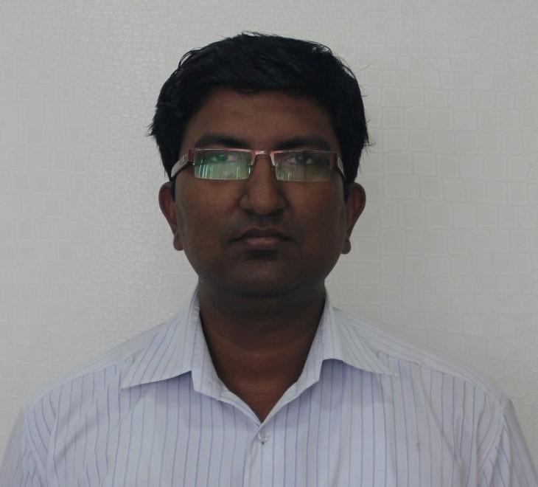
M r. Sanjay Singh, CSE/IT Labs Tech. Coordinator and Asst. Sys. Mgr., D.o.J.: Sep 25, 2007
Specialization: Web Designing, Linux, Windows OS, Servers, Network Design
B.A.: Punjabi University, Patiala, 2000
M.Sc. (CS): Kurukshetra University, 2005
Adv Diploma: NIIT, Faridkot 2002
Oracle 8i: STG, Faridkot, 2002
JCHNP(HW/NW): Jetking, Chandigarh, 2006
Red HAT(RHCE): Linux, 2007-

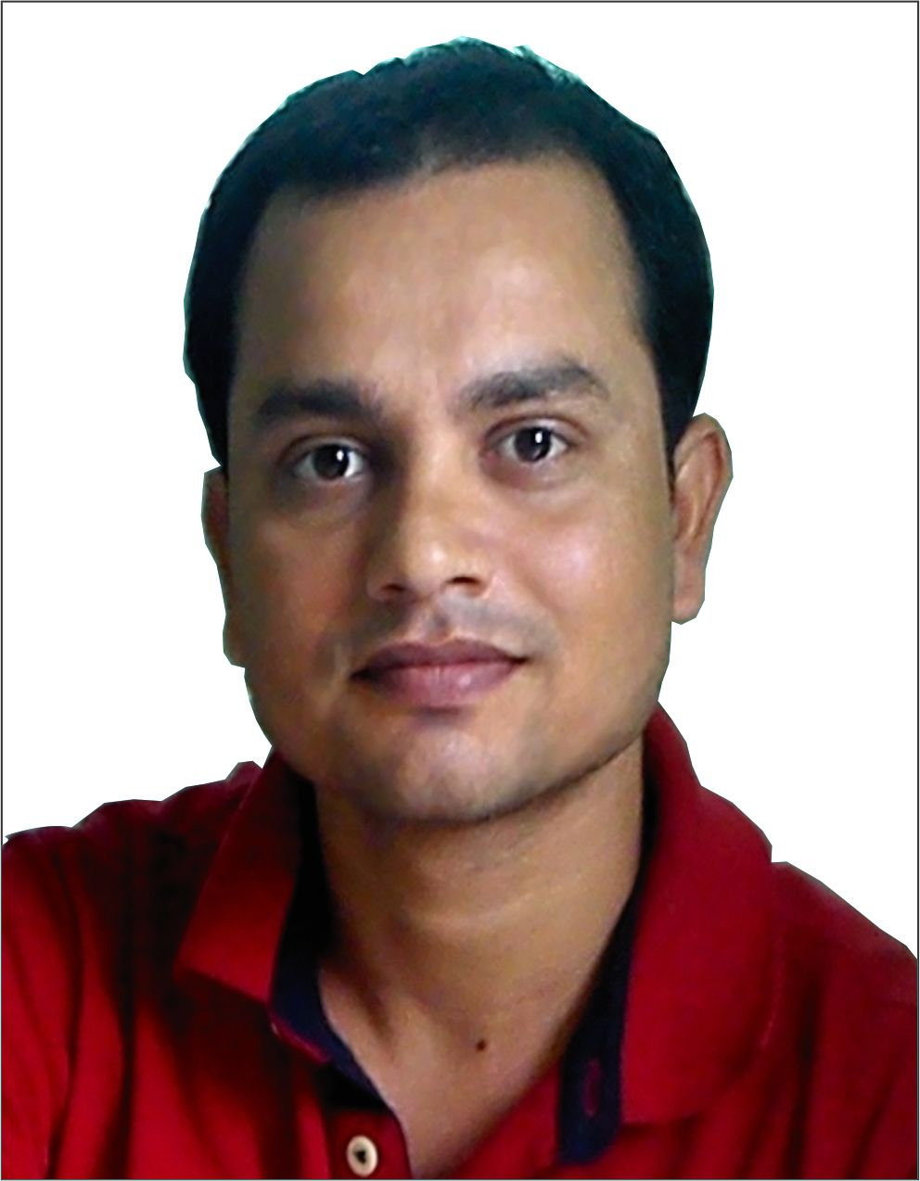
Mr. Alok Kumar Singh, Lab Assistant, D.o.J.: Oct 20, 2008
Specialization: XP, Windows (7, 8), MS Office, Troubleshooting, LAN Installation, Web Designing
B.A: Ranchi University, 2007
ANIIT Diploma: NIIT, Ranchi, 2007

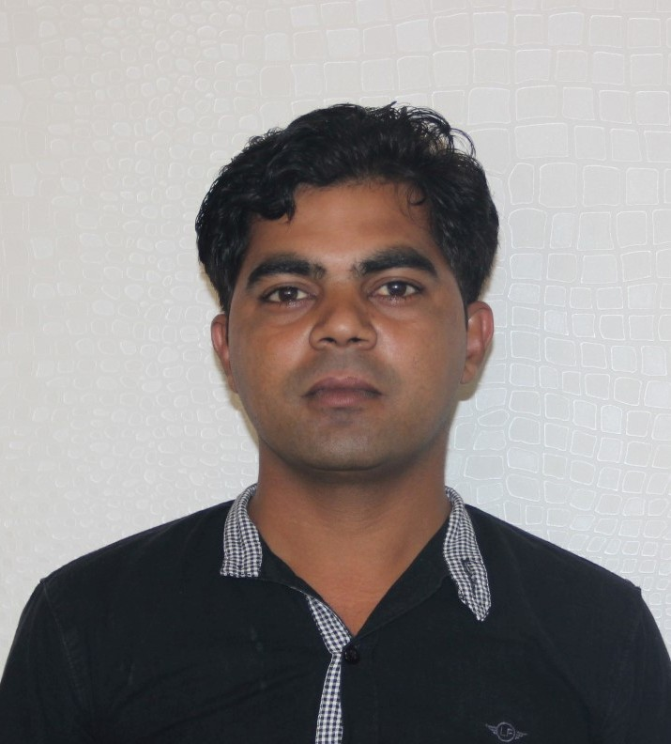
M r. Pardeep Yadav, Lab Assistant, D.o.J.: Aug 28, 2008
Specialization: Software Installation, Troubleshooting, Maintenance, Computer Inventory
Diploma (HN): LBSTI Vikaspuri, New Delhi, 2008
Diploma (IT): LBSTI Vikaspuri, New Delhi, 2008

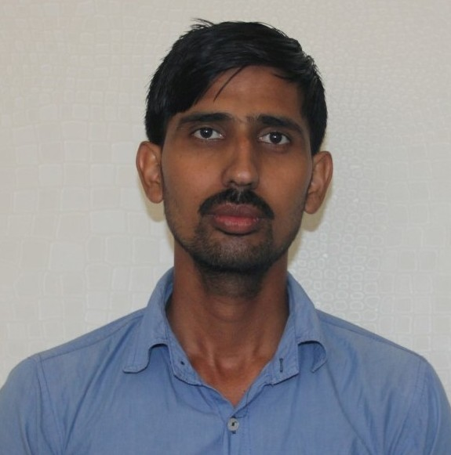
Mr. Manoj Kumar, Technical Assistant, D.o.J.: Feb 25, 2010

Specialization: Software Installation, Troubleshooting, Maintenance, Computer Inventory
Diploma (HN): JETKING Infotrain Ltd., 2008

S.E.T. - Technical Staff - April 2015
Electronics and Communication Engineering
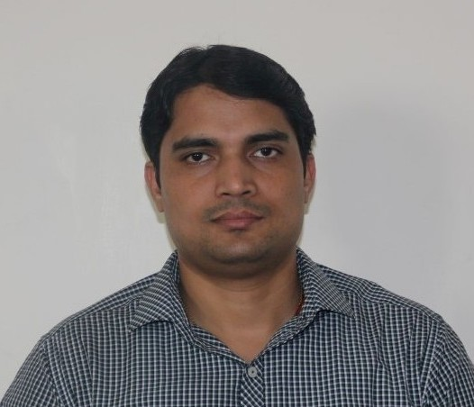
Mr. Antim Dev Mishra, ECE/EEE Labs Tech. Coordinator & Sr. Tech. Off., D.o.J.: Apr 19, 2008
Specialization: Mobile Health Info. Systems, Information and Coding Theory, CDMA Systems
M.Tech. (ECE): GITM Gurgaon/M.D.U., Rohtak, 2013
M.Sc. (Phy): Purvanchal University, Jaunpur, 2002
B.Sc. (PM): Purvanchal University, Jaunpur, 2000

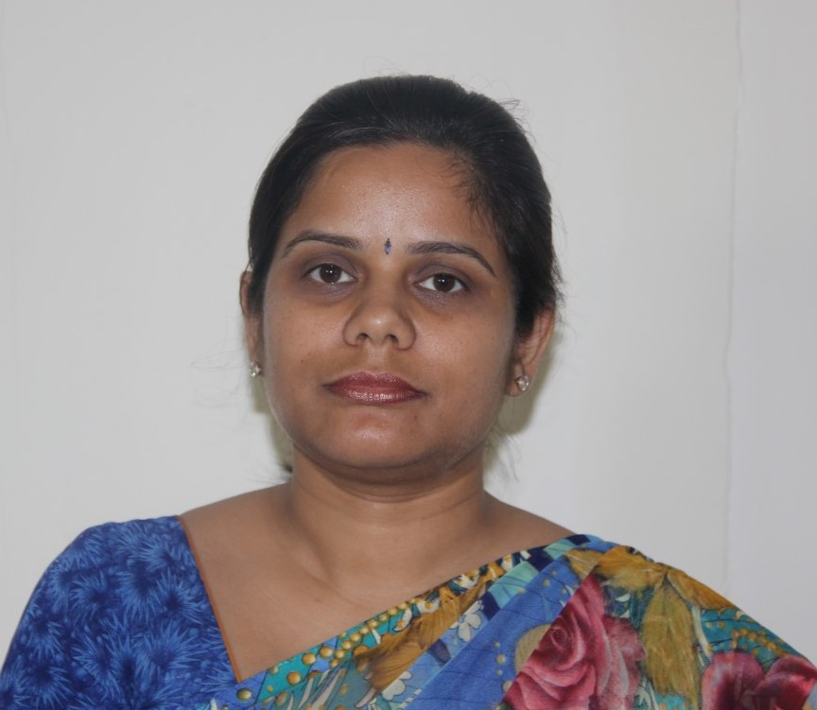
Ms. Surbhi Kulshrestha, Lab Technician, D.o.J.: Oct 21, 2010
Specialization: Digital Electronics, Communication Systems, Circuit & System, Analog Electronics
A.M.I.E. (ECE): The Institution of Engineers, Kolkata, 2014
Diploma (ECE): Govt. Women’s Polytechnic College, 2002

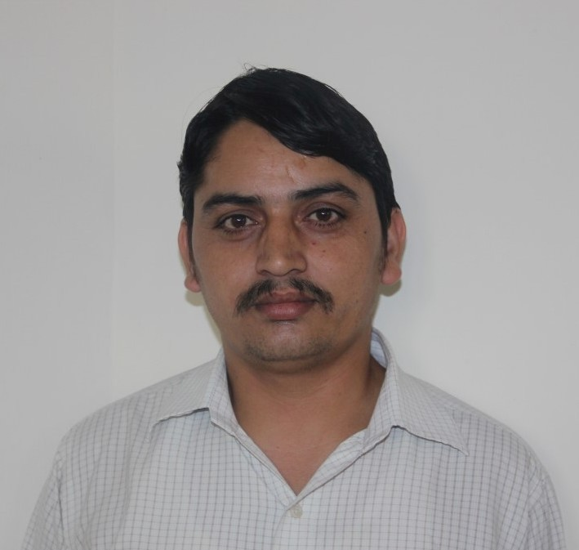
Mr. Suresh Kumar, Lab Technician, Do.J.: Sep 6, 2010
Specialization: Electrical Sciences, EMEC, Power System, EMI, Utilization, Instrumentation
Diploma (EE): Rajasthan Vidyapeeth University, Udaipur, 2011
I.T.I. (EE): I.T.I., Chamba, H.P., 1998
Apprentice: Maruti Suzuki, Gurgaon, 2000

S.E.T. - Technical Staff - April 2015
Electrical and Electronics Engineering
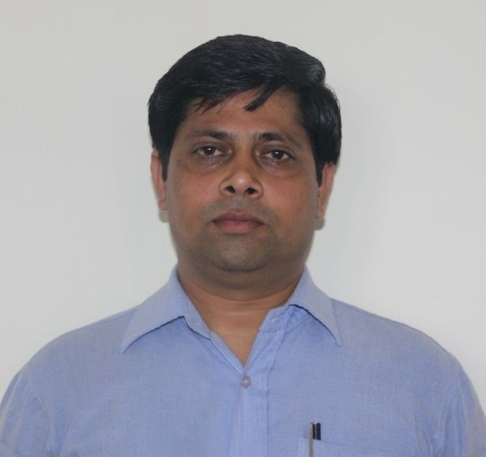
M r. Pawan Kumar Sharma, Lab Assistant, Do.J.: Aug 1, 2008
Specialization: Circuits and System, DSP, VLSI, VHDL, Electrical Circuit, Digital Electronics
I.T.I. (Electrical): I.T.I., Pusa, Jahagir Puri, New Delhi, 1993

S.E.T. - Technical Staff - April 2015
Mechanical Engineering
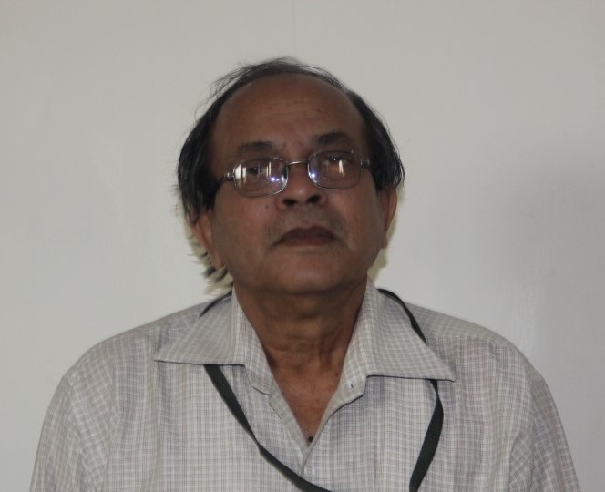
Mr. Asoke Adhikary, Workshop Superintendent, D.o.J.: Aug 19, 2008
Specialization: EM, BME, ICE
Diploma (L.M.E.): State Council for Engineering and Technical Education, 1976

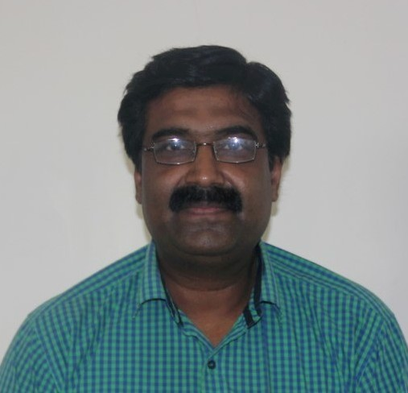
Mr. Bikash Dey, Workshop Instructor, D.o.J.: Sep 10, 2008
Specialization: EM, BME, Workshop, SOM and MS
ITI (Welding): I.T.I., Malaviya Nagar, New Delhi, 1986
Apprenticeship: BEL, Sahibabad, New Delhi, 1987

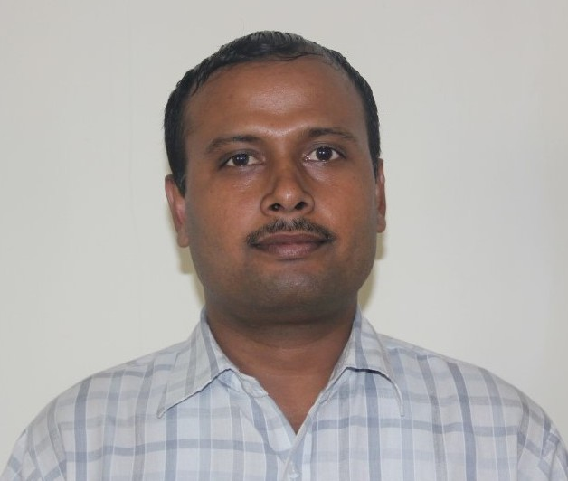
Mr. Anil Kumar, Workshop Instructor, D.o.J.: Se 5, 2008
Specialization: Workshop, KOM, FM, Automobile
I.T.I. (Carpentry): I.T.I., Nalwa, Hisar, 2005

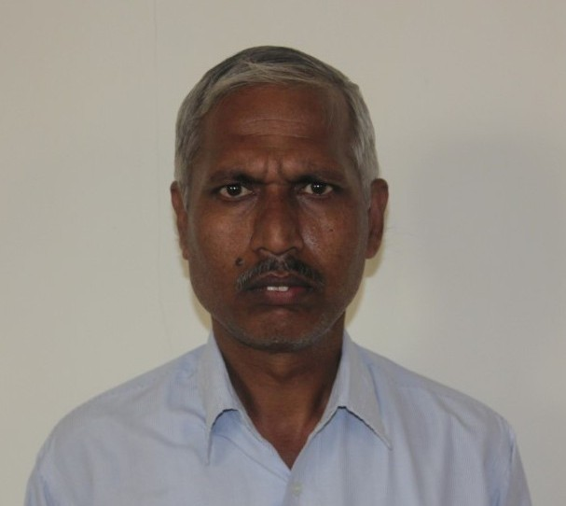
Mr. Rajender Singh, Workshop Instructor, D.o.J.: Aug 13, 2013
Specialization: Workshop, Manufacturing Processes, Soil Mechanics, FM, Surveying
I.T.I. (Machining): I.T.I., Palwal, Haryana, 1985
Apprentice: Prakash Agro Industries, Faridabad, 1986

S.E.T. - Technical Staff - April 2015
Civil Engineering
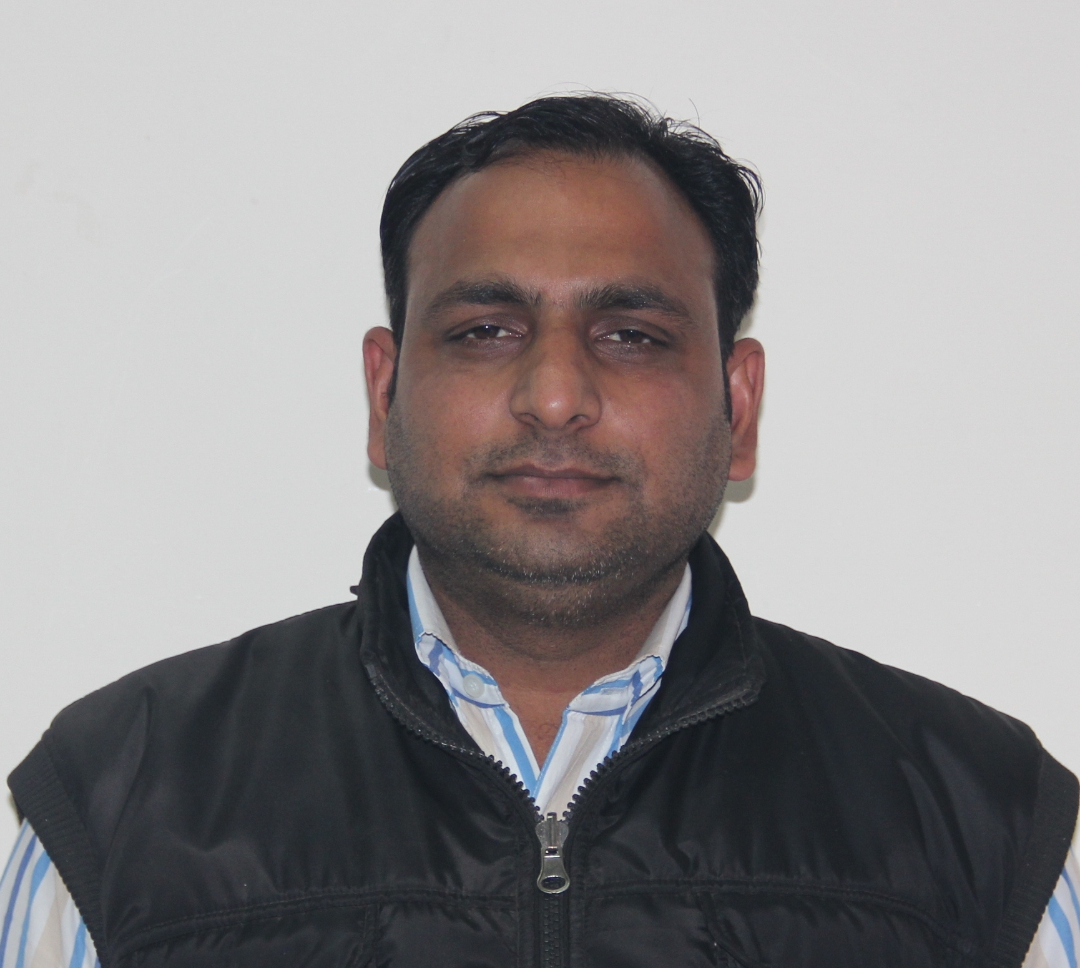
Mr. Raj Yadav, Lab Technician, D.o.J.: Oct 13, 2014
Specialization: BMC, Concrete, FM, Survey, TE
Diploma: Govt. Polytechnic, Moradabad, 2008

S.E.T. - Scientific Staff - April 2015
Applied Sciences
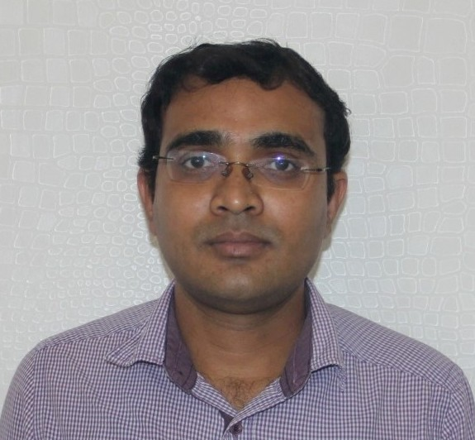
Mr. Anupam Adhikary, Sr. Technical Assistant, D.o.J.: Aug 14, 2006
Specialization: Engineering Chemistry, General Chemistry, Organic Chemistry, Biotechnology
B.Sc. (Hon.): Vinoba Bhave University, Hazaribagh, 1997
EMBA: National Institute of Management, 2009

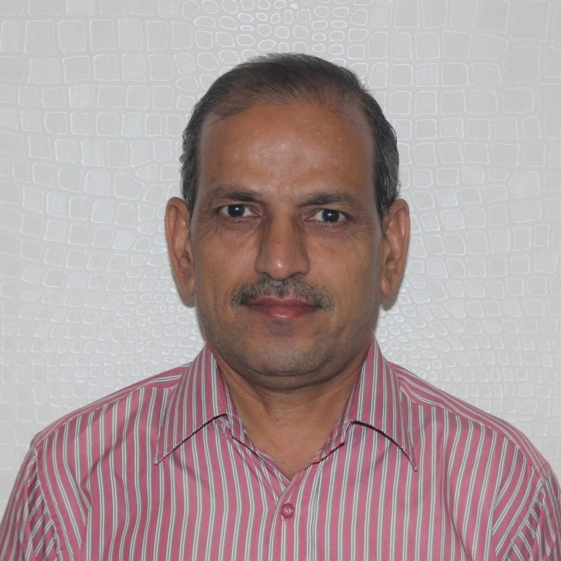
Mr. K.C. Gupta, Lab Assistant, D.o.J.: Nov 15, 2007
Specialization: Engineering Physics, Computational Physics, Applied Physics
XII: Dayanand Public School, Faridabad, CBSE Board, 1981

S.E.T. - Office Staff - April 2015
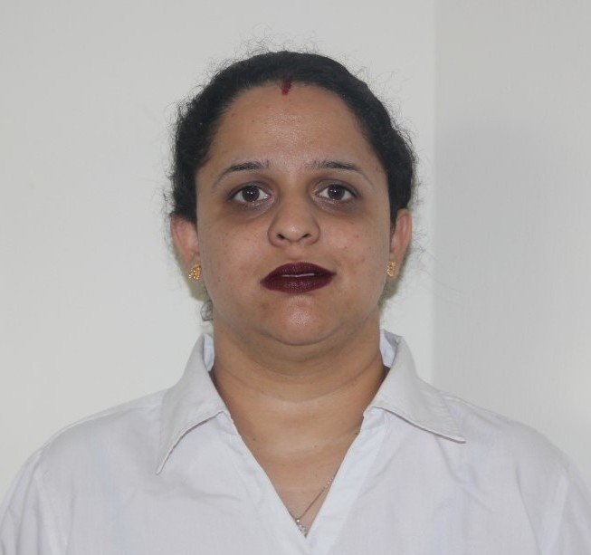
Ms. Ekta Nanchahal, Sr. Coordinator, D.o.J.: May 2, 2005
Specialization: Executive Support, Overall Office Coordination of School/Depts., MS Office Suite, Interpersonal Skills, Executive Communications
M.Sc. (CS): M.D. U., Rohtak, 2004
B.A.: Delhi University, 2001
GNIIT Diploma: NIIT, New Delhi, 2001

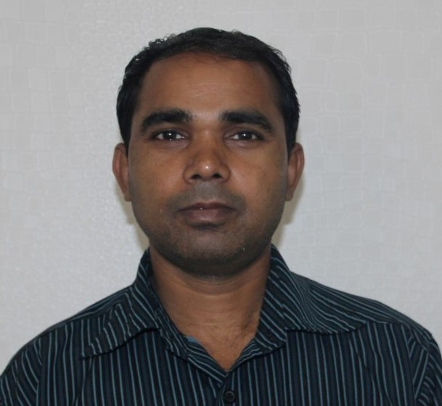
Mr. Ajay Kumar, Attendant, D.o.J.: Nov 22, 2006
Specialization: Overall Support - School/Depts.

