S.E.T. - Faculty - April 2015
Computer Science and Engineering
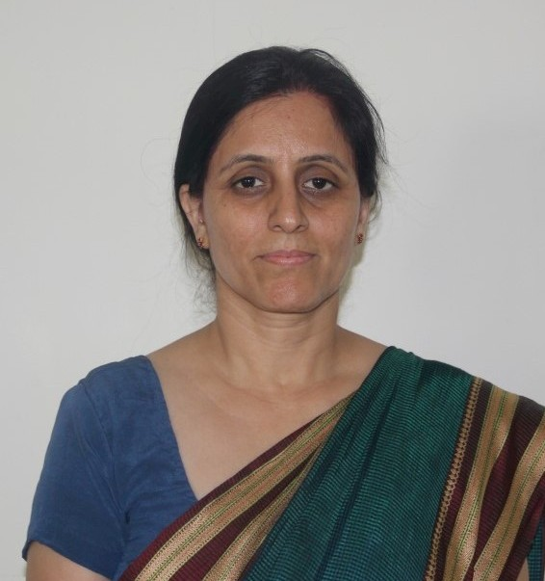
Ms. Alpana Jijja, CSE Dept. Coordinator and Assistant Professor, D.o.J.: Aug 8, 2008
Research: Neural Networks, Cloud Computing, Computer Networks
B.E.: College of Engineering, Osmanabad/ Marathwada University, Aurangabad, 1993
M.Tech.: Dronacharya College of Engineering/ JNR Rajasthan Vidya Peeth University, 2006
M.B.A.(IT): Distance Education/ Sikkim Manipal University, 2011
(Ph.D.): Ansal University (Pursuing)

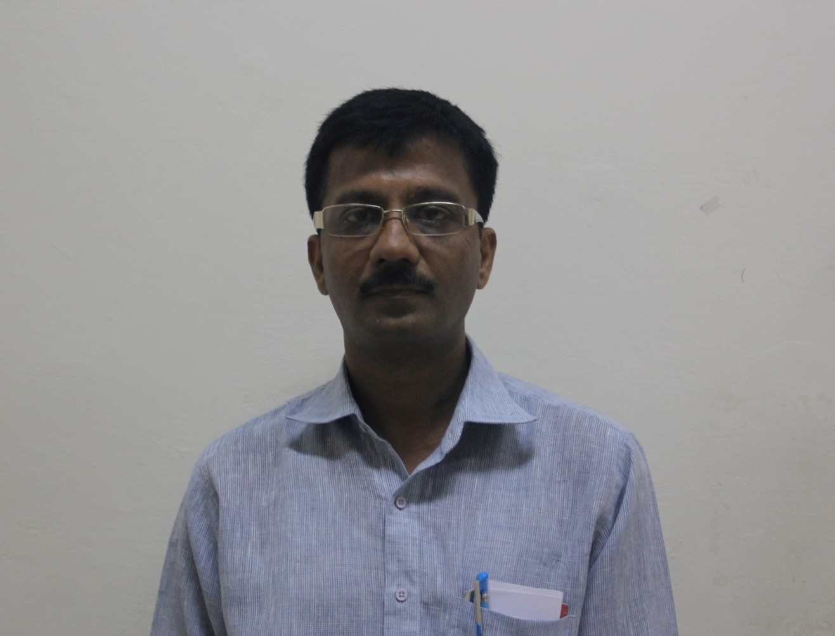
Mr. Goutam Datta, CSE/IT Labs Coordinator and Assistant Professor, D.o.J.: Aug 29, 2014
Research: Information Retrieval, Machine Learning, Soft Computing, Big Data Analytics
Diploma: Board of Technical Exams, Maharashtra, 1993
B.E.: College of Engineering, Badnera/Amravati University, Amravati, 1997
M.Tech.: Ramanujan Institute of Engg. & Mgmt./IASE University, Rajasthan, 2005
(M.Tech.): Advanced College of Engg. & Tech./M.D.U. (pursuing)

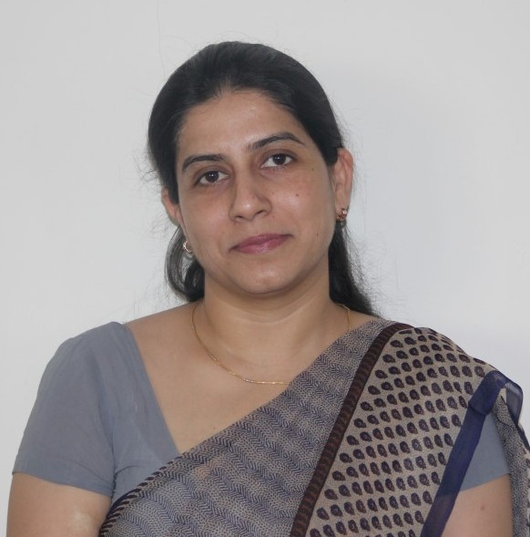
Ms. Sherry Verma, Assistant Professor, D.o.J.: Jul 10, 2010
Research: Database Management Systems, Data Mining, Social Network Analysis
B.E.: Shri Baba Mastnath Engineering College, Rohtak/ M.D.U., Rohtak, 2001
M.Tech.: Dept. of Computer Science and Applications/ Kurukshetra University, 2004
(Ph.D.): Ansal University (Pursuing)

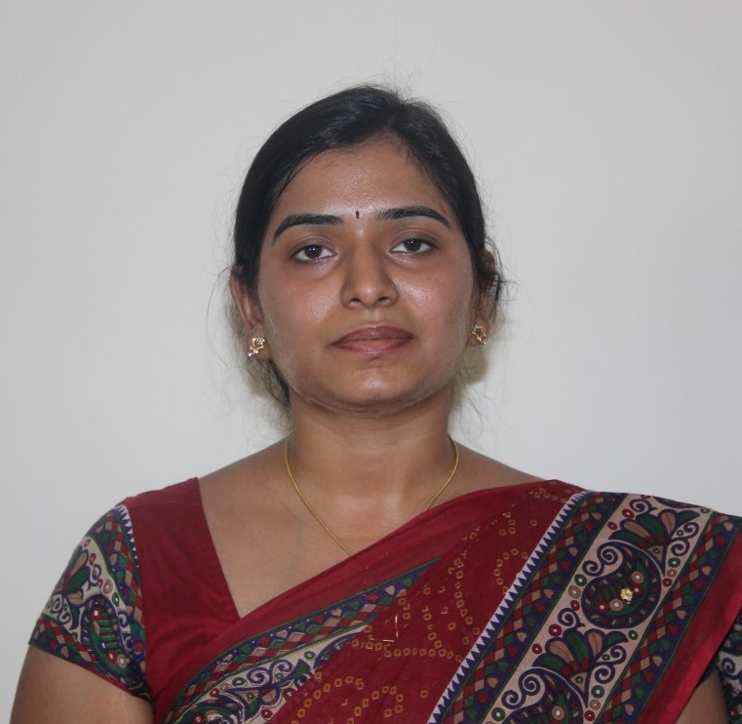
Ms. Rewa Sharma, Assistant Professor, D.o.J.: Sep 9, 2010
Research: Adhoc Networks, Power Management in MAC Layer, Data Mining
B.Tech.: T.I.T.S., Bhiwani/ M.D.U., Rohtak, 2009
M.Tech.: Dept of Computer Science/ Banasthali University, 2011
(Ph.D.): Banasthali University (Pursuing)

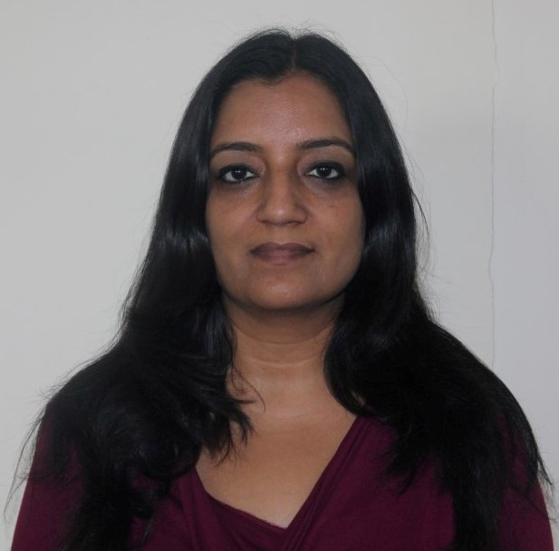
Ms. Pramneet Kaur, Assistant Professor, D.o.J.: Jul 1, 2011
Research: Image Analysis, Steganography, Computer Graphics
B.Tech.: Cummins College of Engineering, Pune/ Pune University, 1997
M.E..: NSIT, Delhi/ Delhi University, 2010

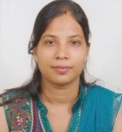
Ms. Rashi Gupta, Assistant Professor, D.o.J.: Aug 16, 2011
Research: Algorithms & Computational Theory, Improving Software Quality using Fuzzy Logic
B.Tech.: VCE, Rohtak/ M.D.U., Rohtak, 2007
M.Tech.: VCE, Rohtak/ M.D.U., Rohtak, 2010

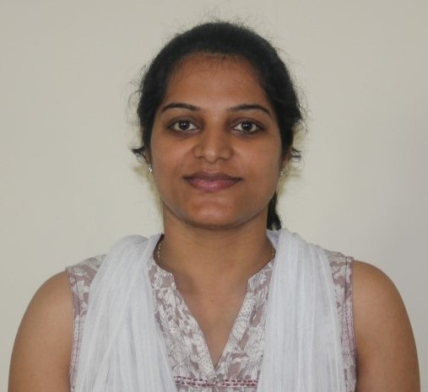
Ms. Shilpa Mahajan, Assistant Professor, D.o.J.: Aug 16, 2011
Research: Network Security and Cryptography, Data Warehousing and Data Mining,
Software Engineering
B.Tech.: Beant College of Engineering & Technology/ P.T.U., Jalandhar, 2006
M.E.: Univ. Institute of Engineering & Tech./ Punjab University, Chandigarh, 2010
M.B.A. (IT): Distance Education/ Punjab Technical University, 2009

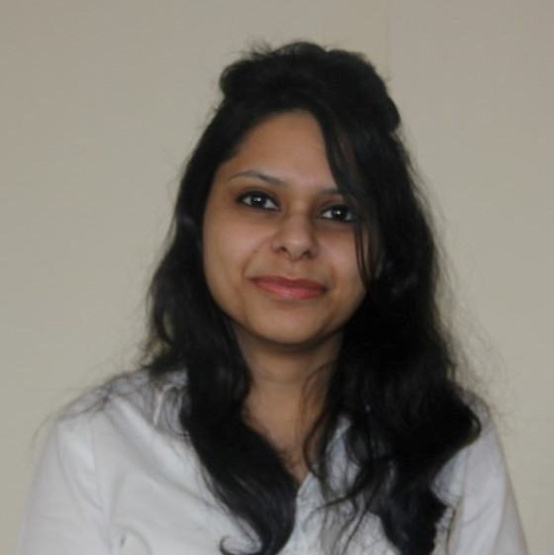
Ms. Vaishali Arya, Assistant Professor, D.o.J.: Aug 16, 2011
Research: Cloud Computing, Software Engineering, Network Security
B.E.: Dronacharya College of Engineering, Gurgaon/ M.D.U., Rohtak, 2009
M.Tech.: Institute of Technology & Management, Gurgaon/ M.D.U, Rohtak, 2011

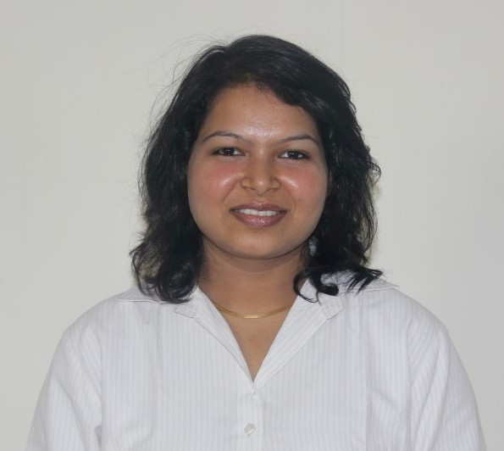
Ms. Monika Roopak, Assistant Professor, D.o.J.: Aug 25, 2011
Research: Ad hoc Networks, , Artificial Intelligence, Analysis of Algorithm
B.Tech..: Faculty of Engineering and Technology, Jamia Nagar/ Jamia Millia Islamia, 2008
M.Tech.: University School of Information Tech., Dwarka/ GGSIPU, 2011

S.E.T. - Faculty - April 2015
Electronics and Communication Engineering
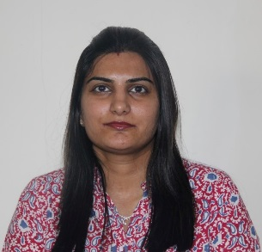
Ms. Garima Bakshi, B.Tech. Coordinator, Assistant Professor, D.o.J.: Jun 19, 2010
Research: VLSI Design, Antennas, Digital Circuits
B.E.: Lingaya’s Institute of Management &Technology/ M.D.U., Rohtak, 2004
M.Tech.: Apeejay College of Engineering, Sohna Road/ M.D.U., Rohtak, 2008
P.G.D.M.: AIMA, 2006
(Ph.D.): Ansal University (Pursuing)

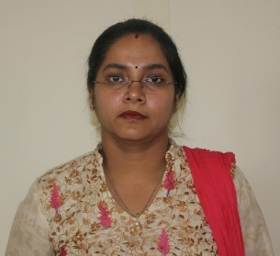
Ms. Rakhi Dua, ECE Dept. Coordinator and Assistant Professor, D.o.J.: Jul 17, 2010
Research: Antenna Design, Optical Communication, Neural Network
B.Tech.: T.I.T.S., Bhiwani/ M.D.U., Rohtak, 2003
M.Tech.: ITM, Gurgaon/ M.D.U., 2009
M.B.A. (HR): Distance Education/Kurukshetra University, 2005
(Ph.D.): J.J.T.U., Jhunjhunu (Pursuing)

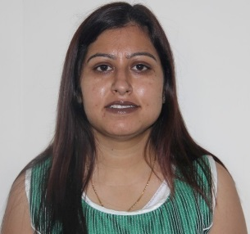
Ms. Bindu Thakral, Assistant Professor, D.o.J.: Sep 4, 2010
Research: VLSI, Microprocessor based Circuits, Filter design
B.Tech.: Vaish College of Engineering, Rohtak/ M.D.U., Rohtak, 2004
M.Tech.: Lingayas Inst of Management and Technology, Faridabad/ M.D.U., Rohtak, 2008
(Ph.D.): Ansal University (Pursuing)

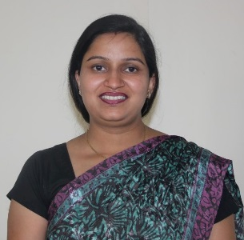
Ms. Meha Sharma, Assistant Professor, D.o.J.: Oct 12, 2010
Research: Lasing Nanoheterostructures, Double Heterostructures,
Semiconductor Optoelectronics
B.E.: Career Institute of Technology and Management/ M.D.U., 2005
M.E.: Lingayas Institute of Management and Technology/ M.D.U., 2008
(Ph.D.): Banasthali University (Pursuing)

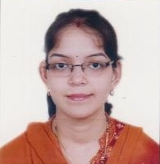
Ms. Priyanka Mathur, Assistant Professor, D.o.J.: Sept 1, 2011
Research: Digital Image Processing, Biometrics
B.E.: Jabalpur Engineering College/ R.G.P. Vishwavidhyalaya, 2008
M.Tech.: IIITDM, Jabalpur, 2010
S.E.T. - Faculty - April 2015
Electrical and Electronics Engineering
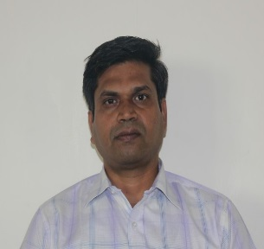
Dr. U.K. Choudhury, S.E.T. Ph.D. Coordinator and Associate Professor, D.o.J.: Jul 3, 2010
Research: Power System Stability, Application of AI Techniques in Power Systems
B.E.: University College of Engineering/ Sambalpur University, Burla, 1995
M.E.: Delhi College of Engineering/ Delhi University, 2001
Ph.D.: Faculty of Engineering and Tech./ Jamia Millia Islamia, 2008

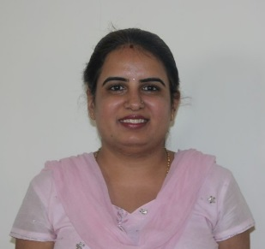
Ms. Harsha Vanjani, EEE Dept. Coordinator and Asst Professor, D.o.J.: Jun 4, 2010
Research: Power Electronics, Soft Computing Techniques, Power Quality
B.E.: L.E. College, Morbi/ Saurashtra University, Rajkot, 2004
M.Tech.: Nirma Institute of Technology/ Nirma University, 2006
(Ph.D.): Ansal University (Pursuing)

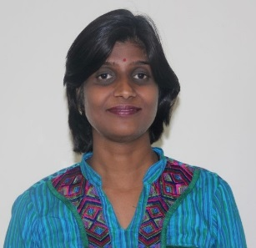
Ms. Neha Gupta, ECE/EEE Labs Coordinator and Assistant Professor, D.o.J.: Sep 1, 2011
Research: Renewable Energy Sources, Power Systems
B.Tech.: Adesh Institute of Engg. & Tech, Faridkot / PTU, Jalandhar, 2001
M.Tech.: Thapar Institute of Engg. & Tech (Deemed Univ.), Patiala , 2003
(Ph.D.): Manav Bharati University, Solan, HP (Pursuing)

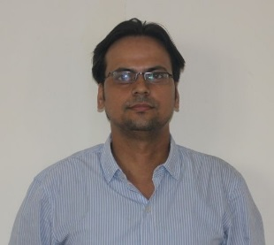
Mr. Sumit Kumar Maitra, Assistant Professor, D.o.J.: Jan 27, 2010
Research: Energy Conservation, Renewable Energy System, Power Quality,
Power Restructuring & Deregulation
B.E.: Laxmi Narain College of Tech./ Rajiv Gandhi Technical University, Bhopal, 2002
M.Tech.: Nirma Institute of Technology/ Nirma University, Ahmedabad, 2005
(Ph.D.): School of Engineering/ R.K. University, Rajkot (Pursuing)
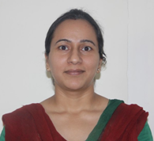
Ms. Megha Khatri, Assistant Professor, D.o.J.: Aug 1, 2012
Research: Power Quality, Power System, Instrumentation & Control, DSP
B.Tech.: Chitkara Institute of Engg. and Technology, Jansla. Patiala/ P.T.U., 2007
M.Tech.: Deenbandhu Chotu Ram Univ. of Sciences & Tech. (Deemed Univ.), Murthal, 2009
(Ph.D.): Ansal University (Pursuing)
S.E.T. - Faculty - April 2015
Mechanical Engineering

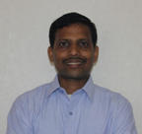
Dr. Subhash Anurag, ME Dept. Coordinator and Associate Professor, D.o.J.: Jul 15, 2014
Research: Finite Element Analysis, Manufacturing Processes, Tool Design, Surface Integrity,
Mechanical Behavior of Materials
Post Diploma: YMCA Inst. of Engineering/ Haryana State Board of Technical Education, 1996
(4 Year)
Adv Diploma YMCA Inst. of Engineering, 1999
M.S.: College of Engineering/ University of Alabama, USA, 2008
Ph.D.: College of Engineering/ University of Alabama, USA, 2008

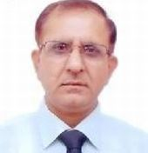
Mr. Yugal Kishore, CE Dept & M.Tech. Coordinator, D.o.J.: Feb 23, 2011
Research: Design with Finite Element Analysis, Renewable Energy Resources, Design of Systems
B.E.: Naval College of Engineering, Lonavale, Pune/ U. of Poona, 1984
M.E.: Institute Armament Technology, Girinagar/ U. of Poona, 1989

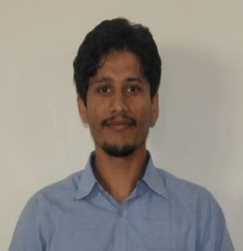
Mr. Paramvir Gulia, ME/CE Labs Coordinator and Assistant Professor, D.o.J.: Jan 17, 2013
Research: Solar Thermal Energy, Refrigeration & Air-Conditioning, Heat Exchangers
B.E.: Deenbandhu Chotu Ram Univ. of Sciences & Tech. (Deemed Univ.), Murthal, 2009
M.E.: SVNIT, Surat-Gujarat, 2011

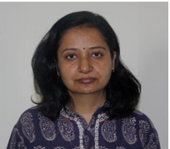
Ms. Somya Tiwari, Assistant Professor, D.o.J.: Aug 3, 2010
Research: Wind Turbine, Solar Energy and Energy Estimation
B.E.: Govt. Engg. College/ Pt. Ravi Shankar Shukla University, Raipur, 1999
M.E.: Maulana Azad National Institute of Technology , Bhopal, 2005
(Ph.D.): Ansal University (Pursuing)

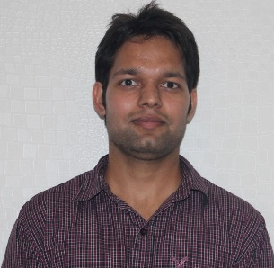
Mr. Hitesh Gahlwat, Assistant Professor, D.o.J.: Jul 15, 2014
Research: Heat & Mass Transfer, Refrigeration & Air Conditioning, Strength of Materials
B.Tech.: Kurukshetra Inst.of Tech. & Mgmt, Kuruskhetra/ Kurukshetra University, 2011
M.Tech.: SVNIT, Surat, 2014

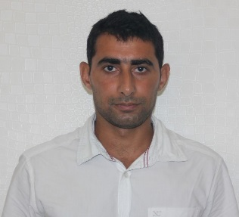
Mr. Manoj Dahiya, Assistant Professor, D.o.J.: Jul 15, 2014
Research: Vibration Analysis, Noise Pollution Modeling, Noise Barriers
B.E.: Deenbandhu Chotu Ram Univ. of Sciences & Tech. (Deemed University), Murthal, 2009
M.E.: NIT, Kurukshetra, 2013

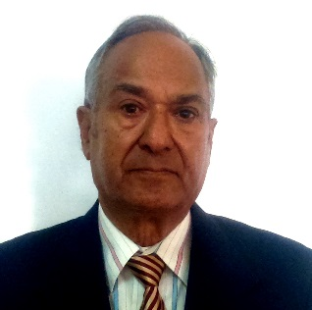
Mr. K.B. Sehgal, Visiting Faculty
Research: Product Design and Development with Quality Function Deployment
B.Sc. (Engg): Banaras Engineering College/ Banaras Hindu University, Varanasi, 1964
M.Tech.: M.D. U., Rohtak, 1968

S.E.T. - Faculty - April 2015
Civil Engineering
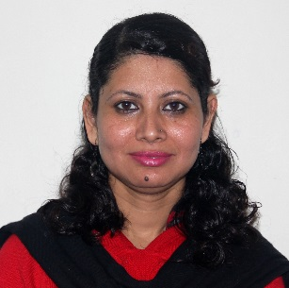
Ms. Ritu Kaushik, Visiting Faculty
Research: Energy and Environment, Solar Energy
B.Sc. : M.M.H. Degree College/ Meerut University, 1999
M.Sc.(Zoology): M.M.S. College/CCS University, Meerut, 2001
M.Sc. (Env. Sc.): Distance Education/ Sikkim Manipal University, 2008
M.Phil. (Env Sci): Distance Education/ Global Open University, 2010
M.Tech.: Dept. of Energy and Environment /Deenbandhu Chhoturam University, Sonepat, 2011
MBA (HR/IT): IMT, Ghaziabad, 2015
(Ph.D.): GGSIP University (Pursuing)

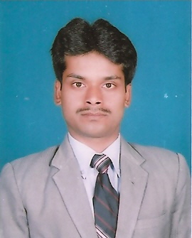
Dr. Kumar Abhishek, Visiting Faculty
Research: Hydrology, Remote Sensing, Geology
B.Sc.(Geology): St. Columbus College/ Vinoba Bhave University, Hazaribagh, 1999
M.Sc.(Geology): St. Columbus College/ Vinoba Bhave University, Hazaribagh, 2002
M.Tech.: Indian Inst of Remote Sensing, Dehradun/Andhra University, 2006
Ph.D.: Dept. of Geology/ Kumaon University, Nainital, 2013

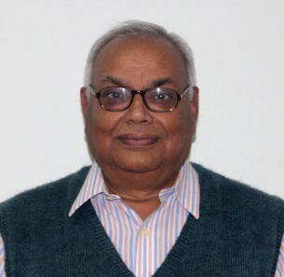
Mr. K.A.P. Singh, Visiting Faculty
Research: Equipment Foundation and Earthquake Engineering
B.Sc.(Engg.): Bihar College of Engineering / Patna University, 1972

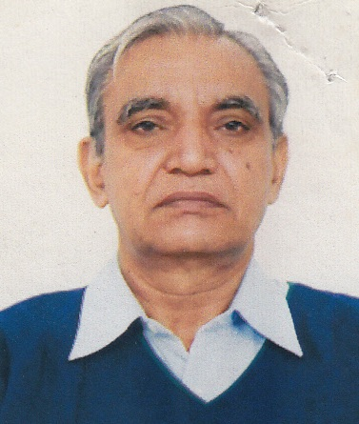
Mr. R.N. Malik, Visiting Faculty
Research: Hydro Power / Water Resources, Sanitation, New Townships, Solar Energy,
Environment
B.Sc. (Engg): PEC, Chandigarh / Panjab University, Chandigarh, 1968
M.Sc. (Engg): PEC, Chandigarh/ Panjab University, Chandigarh, 1975
PGD (Hydro): DELFT University, Holland, 1975
M.Sc. (Pub Hlth):All India Institute of Hygiene and Public health/ Calcutta Univ

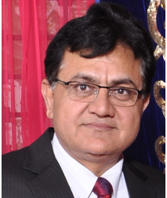
Mr. Dinesh Goel, Visiting Faculty
Research: Project Management, Highway Engineering
B.Sc.: M.M. College, Modinagar/ Meerut University, 1983
B.E. (Civil): Regional Engineering College, Srinagar/ U. of Kashmir, 1987

S.E.T. - Faculty - April 2015
Computer Applications

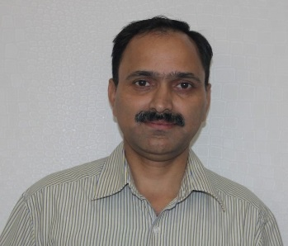
Mr. Sandeep Badhani, BCA and MCA Coordinator, BCA Dept Coordinator and
Asst Professor, D.o.J.: Aug 18, 2006
Research: Algorithm Design, Programming Languages & Implementation, Graph Theory
B.Sc. (PCM): Govt. PG College, Uttarkashi/ H.N.B. Garhwal University, Shrinagar, 1991
MCA.: Science College, Haridwar/ Gurukul Kangri University, Haridwar, 1997

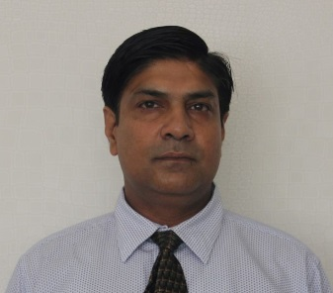
Dr. S.K. Sharma, MCA Dept Coordinator and Asst Professor, D.o.J.: Jul 2, 2008
Research: Artificial Neural Networks, Machine Learning, Soft Computing
M.Sc. (Phy): Dept of Physics/ U. of Roorkee, 1997
M.Phil (Phy): Dept. of Physics/ Choudhary Charan Singh University, Meerut, 1998
M.Tech.: Dept. of Computer Science/ Guru Jambheshwar University, Hisar, 1999
Ph.D.: USICT, GGSIPU, Delhi, 2014


Ms. Shikha Gupta, Assistant Professor, D.o.J.: Aug 2, 2002
Research: IT Security, Cloud Computing, Cyber Security
B.Sc..: Dept. of Science/ Banasthali Vidyapeeth, 1992
MCA.: Dept. of Computer Science/ Banasthali Vidyapeeth, 1995
(Ph.D.): College of CS & IT/ Teerthanker Mahaveer University, Moradabad (Pursuing)

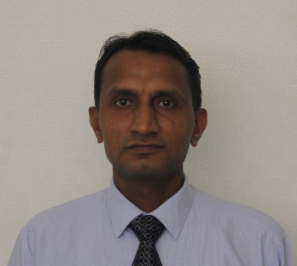
Mr. Ravinder Kumar, Assistant Professor, D.o.J.: Aug 1, 2003
Research: Image Processing, Biometrics, Pattern Recognition, ANN
B.Sc. (CS): CRM Jat College, Hisar/ Kurukshetra University, 1994
M.Sc. (Phy): Dept. of Physics/ Kurukshetra University, 1996
M.Tech.: Guru Jambheshwar University of Science & Technology, 1998
(Ph.D.): Guru Gobind Singh Indraprastha University (Submitted)

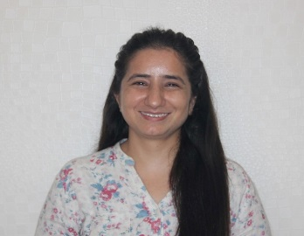
Dr. Kiran Khatter, Assistant Professor, D.o.J.: Jan 3, 2006
Research: Non-functional Requirements, Image Processing, Data Mining,
Soft Computing
B.Sc. (CS): CRM Jat College, Hisar/ Kurukshetra University, 1998
M.B.A. (IT): Dept. of Business Management/ M.D.U., 2000
M.Tech.(IT): Dept. of Information Technology/ Punjabi University, Patiala, 2004
Ph.D.: Himachal Pradesh University, 2015

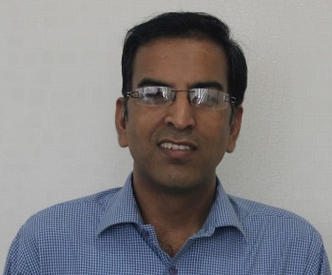
Dr. Dinesh Rai, Assistant Professor, D.o.J.: Nov 17, 2007
Research: Educational Data Mining, Network Mgmt, Design & Analysis of Algorithms
B.Sc. (PCM): Govt Science College (Auton.)/ Jiwaji University, 1998
M.Sc. (CS): School of Mathematics & Allied Sciences/Jiwaji University, 1998
M.Tech.: Govt. Engineering Coll., Raipur/ Pt. Ravi Shankar Shukla Univ., Raipur 2003
Ph.D.: School of Computer Science & Engineering, Monad University, Hapur, 2013

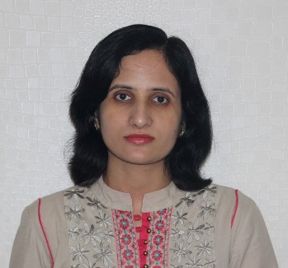
Ms. Deepika Malhotra Arora, Assistant Professor, D.o.J.: Aug 28, 2008
Research: Object Oriented Software Engineering, Data Mining, Artificial Intelligence
BA (English) Govt. PG College, Hisar/Kuruskhestra University, 2000
MCA: Dept of CSE/ Guru Jambheshwar University, Hisar, 2003
M.Phil.: Dept of Computer Science/Chaudhary Devi Lal University, Sirsa, 2007
(Ph.D.): Ansal University (Pursuing)

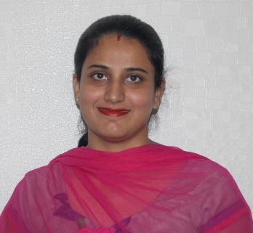
Ms. Kiran Kawatra, Assistant Professor, D.o.J.: Jan 9, 2010
Research: Cloud Computing, Data Mining, Big Data
BCA.: Guru Nanak Girl’s College, Ludhiana/ PTU, Jalandhar, 2002
MCA: Distance Education/M.D.U., Rohtak, 2005
(Ph.D.): Jagadish Prasad Jhabarmal Tibrewala University, Churu, Rajasthan (Pursuing)

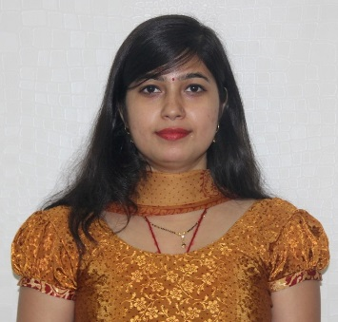
Ms. Vijaya Laxmi Singh, Assistant Professor, D.o.J.: Jul 18, 2010
Research: Reliability on Cloud, Adhoc Networks
B.Sc.(Maths): Shree Shree Lakshmi Narayan Trust Mahila Mahavidyalaya, Dhanbad/
Vinoba Bhave University, Hazaribagh, 2003
BCA: Distance Education/ IGNOU, 2003
M.Sc.(Maths): P.K. Roy Memorial College, Dhanbad/ Vinoba Bhave Univ., 2007
MCA: Distance Education/ IGNOU, 2007
M.Tech.: University School of Information Tech., Kashmere Gate/ G.G.S.I.P.U., 2010
(Ph.D.): Ansal University (Pursuing)

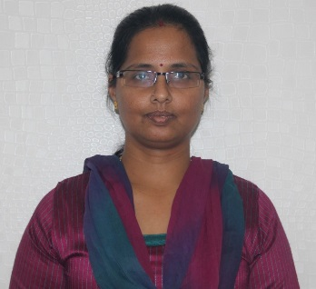
Ms. P. Vidhya Lakshmi, Assistant Professor, D.o.J.: Jul 29, 2010
Research: Cloud Computing, Software Reliability, Data Warehousing & Mining,
Big Data Analytics
B.Sc.(CS): SR College, Trichy/ Bharatidasan University, 1993
M.Sc.(CS): SR College, Trichy/ BharatidasanUniversity, 1995
(Ph.D.): Jagadish Prasad Jhabarmal Tibrewala University, Churu, Rajasthan (Pursuing)

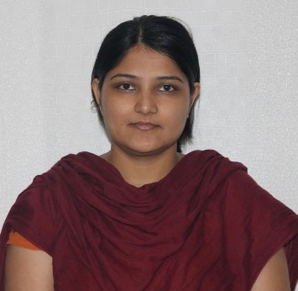
Ms. Jyoti Mor, Assistant Professor, D.o.J.: Aug 9, 2010
Research: Software Engineering, Software Reliability, AGILE, MANET
B.Sc. (PCM): University College, Kurukshetra/ Kurkshetra University, 2005
MCA: Seth Jaiprakash Inst of Tech & Mgmt, Radaur, Yamuna Nagar/
Kurukshetra University, 2008
M.Phil. (CS): Dept of Computer Science/ Chaudhary Devi Lal University, Sirsa, 2012
(Ph.D.): Ansal University (Pursuing)

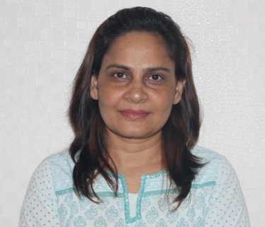
Dr. Monika Chauhan, Assistant Professor, D.o.J.: Dec 11, 2011
Research: Information Systems, Cloud Computing, Data Science
B.Sc. (Electr Sci): Fergusson College, Pune/ Univ. of Pune, 1996
M.Sc. (Electr Sci):Fergusson College, Pune/ Univ. of Pune, 1998
M.C.M.: Symbiosis Inst. of Computer Studies & Research, Pune/ U. of Pune, 2000
M.Phil. (CS): Distance Education/ Periyar University, Salem, 2008
Ph.D.: Monad University, Hapur, 2013

S.E.T. - Faculty - April 2015
Applied Sciences
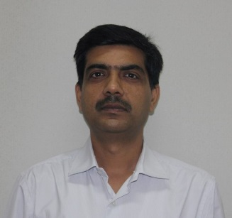
Prof. Atul Kumar, Professor, D.o.J.: Aug 3, 2007
Research: Optical Communication Systems and Networks, Nonlinear Fiber Optics,
High Power Fiber Lasers and Nano-Photonics
B.Sc. (PCM): Vardhman College, Bijnor/ Rohikhand University, Bareilly, 1998
M.Sc.: Dept. of Physics/ University of Roorkee, Roorkee, 1991
Ph.D.: Dept. of Physics/ IIT - Delhi, 1998
Post-Doc: College of Electrical Engineering/ KAIST, S. Korea, 1999
Post-Doc: Dept. of Electronics Engineering/ RCAST, U. Tokyo, 2005
Post-Doc: Dept of MSE/ NCSU, 2009
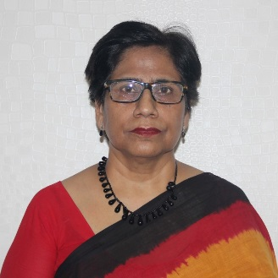
Dr. Neelam Vohra, Associate Professor, D.o.J.: Jul 1, 2005
Research: Bridge-Head Nitrogen- Heterocycles, Synthesis of Insect Sex Pheromones,
Environmental Chemistry
B.Sc. (CZB): Mukand Lal National College, Yamuna Nagar/ Kurukshetra Univ, 1975
M.Sc. (Chem): Dept of Chemistry/ Kurukshetra University, 1977
M.Phill.: Dept of Chemistry/ Kurukshetra University, 198
Ph.D.: Dept of Chemistry/ Panjab University, Chandigarh, 1986

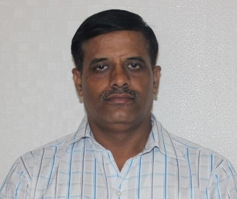
Dr. Y.K. Sharma, Associate Professor, D.o.J.: Oct 1, 2008
Research: Applied Mathematics, Hydromagnetic Flows, Integral & Transform Theory
B.Sc. (PCM): Nanak Chand Anglo-Sanskrit PG College, Meerut/ Meerut University, 1992
M.Sc. (Maths): Nanak Chand Anglo-Sanskrit PG College/ Ch. Charan Singh Univ., Meerut, 1994
Ph.D.: Dr. Bhim Rao Ambedker University, Agra, 2003

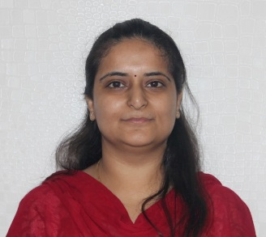
Ms. Shweta Bakshi, Dept Coordinator- App. Sciences, Assistant Professor, D.o.J.: May 1, 2008
Research: Non Liner PDEs and Operations Research
B.Sc.(CS).: S.D College, Panipat/ Kurukshetra University, 2003
M.Sc. (Maths): Dept of Mathematics/ Kurukshetra University, 2005
M.Phil (Maths): Distance Education/ Madurai Kamraj University, 2010
(Ph.D.): Ansal University (Pursuing)

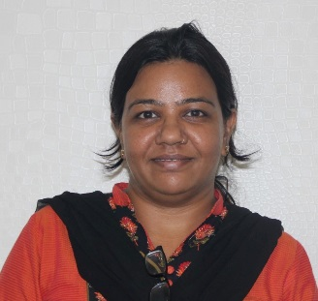
Ms. Neelam Lohiya, -Dept Coordinator -Intl. Students, Assistant Professor, D.o.J.: Sep 20, 2010
Research: Herbal Medicines, Vegetable Oil based Lubricants
B.Sc. (CZB): SSV PG College/ CCS University, Meerut, 1998
M.Sc. (Chem): SSV PG College/ CCS University Meerut, 2001
M.Tech.: HBTI, Kanpur/ UPTU, 2004
(Ph.D.): Ansal University (Pursuing)

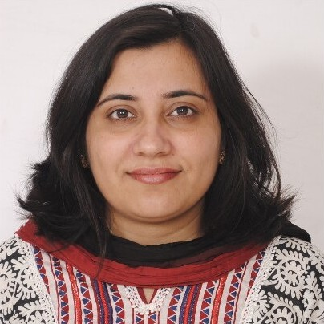
Dr. Monika Khurana, Assistant Professor, D.o.J.: Jul 24, 2008
Research: Biomembranes, Lipid-Protein interactions, Nanoparticle-Biomembrane Interaction
B.Sc.(Hons): Dept of Chemistry/ Panjab University, 1999
M.Sc.(Hons): Dept of Chemistry/ Panjab University, 2001
Ph.D.: Intl. Max-Planck Research School in Chemical Biology, Dortmund, Germany, 2006
Post-Doctoral: Emory University, Atlanta, USA, 2007

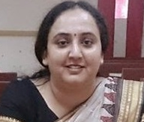
Ms. Anju Rani, Assistant Professor, D.o.J.: Sep 4, 2008
Research: Fluid Dynamics, Heat and Mass Transfer
B.A.(Maths): Adarsh Mahila Maha Vidyalaya, Bhiwani/M.D.U., Rohtak, 1998
B.Ed..: Kirori Mal College, Bhiwani/ M.D.U., Rohtak, 1999
M.Sc.(AM): Dept of Applied Mathematics, Guru Jambheshwar University, Hisar, 2001
M.Phil: Distance Education/ Madurai Kamaraj University, Madurai, 2007
Ph.D.: Ansal University (Pursuing)

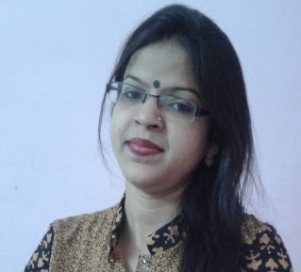
Dr. Manimala, Assistant Professor, D.o.J.: Jun 7, 2010
Research: Mathematical Approach to Game Theory & its Fuzzification,
Vedic Mathematics, Algebra
B.Sc. (Hons): L.S. College, Muzaffarpur/ Bihar University, 2004
PGDCA: Babasaheb Bhim Rao.Ambedkar Bihar University, Muzzafarpur, 2006
M.Sc. (Math): PG Dept/ Babasaheb Bhim Rao.Ambedkar Bihar University, Muzzafarpur, 2007
Ph.D.: PG Dept/ Lalit Narayan Mithila University, Darbhanga, Bihar, 2014

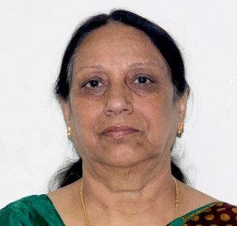
Dr. Veena Bhatnagar, Visiting Faculty
Research: Spectroscopy, Paramagnetic Resonance
B.Sc.: Meerut College/ Meerut University, Meerut, 1971
M.Sc.: Meerut College/ Meerut University, Meerut, 1973
Ph.D.: Dept. of Physics/ M.D. U., Rohtak, 1993

