Even 2024 Backlog EForms Help file

- Navigate to https://www.tcsion.com/SelfServices/
- Insert your login credentials then Click "Login"
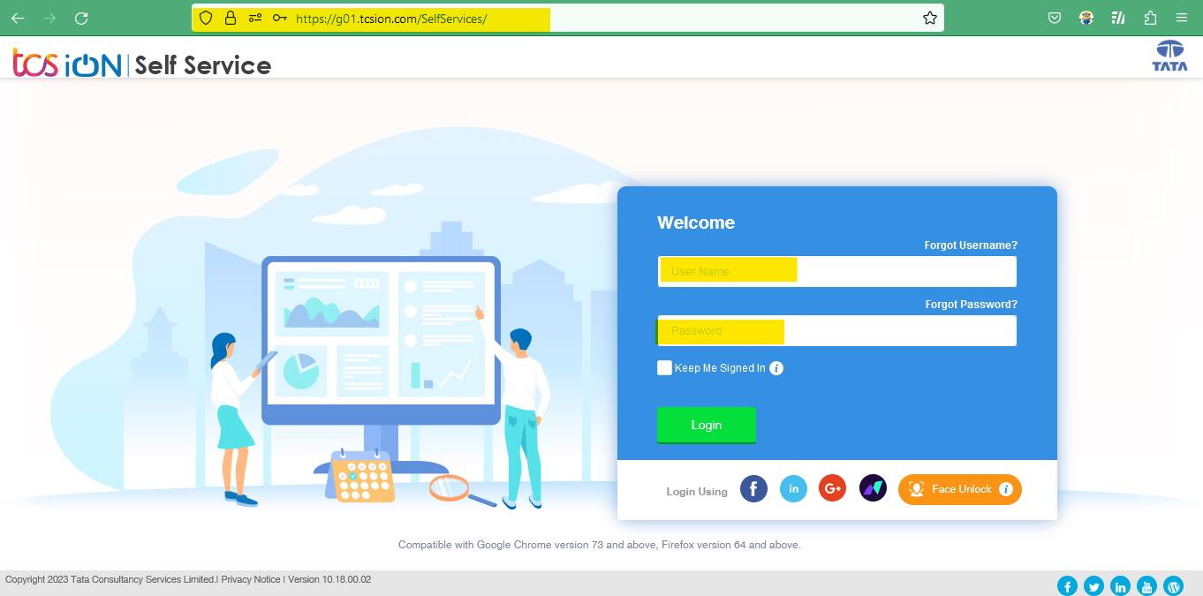

- Click "Exam Registration Form/Admit Card Download"
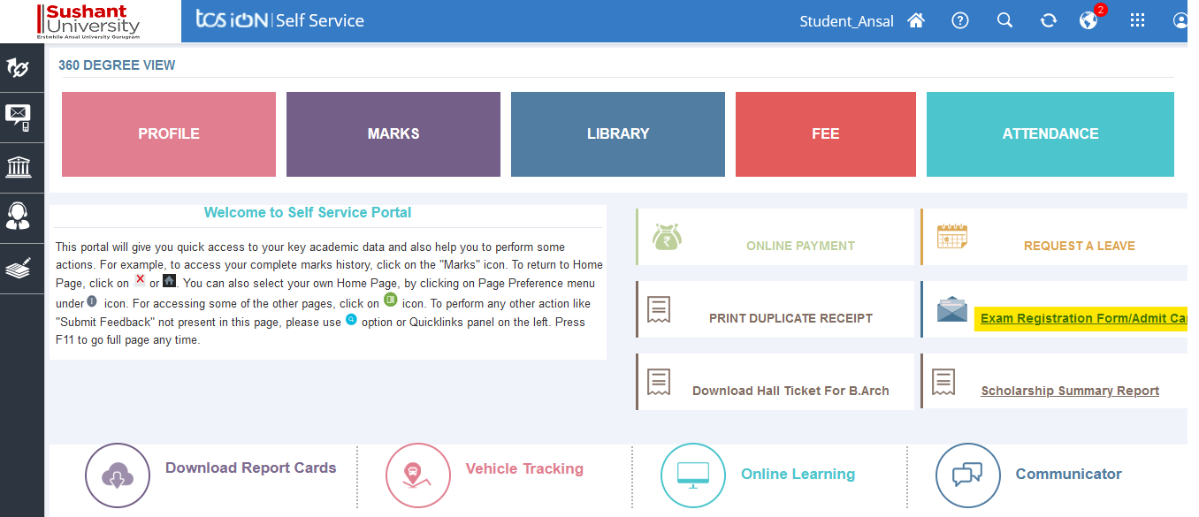

- Click "Exam Enrollment"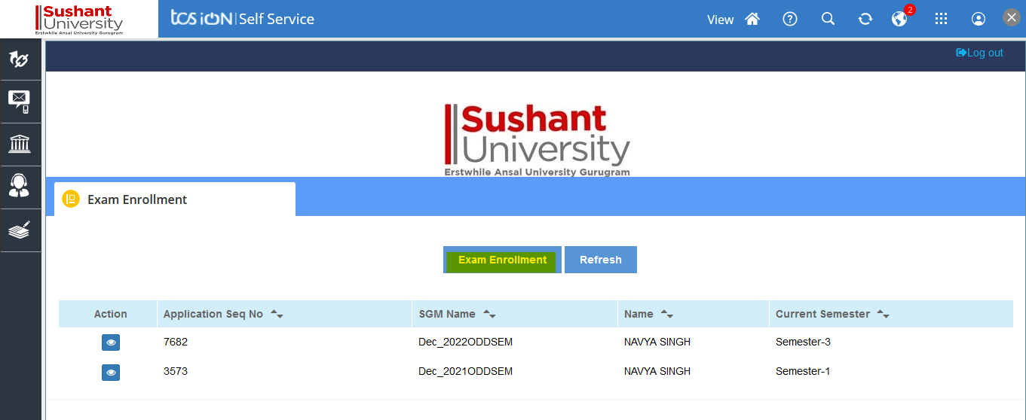

- In subject enrollement details Click plus icon to view to the subject.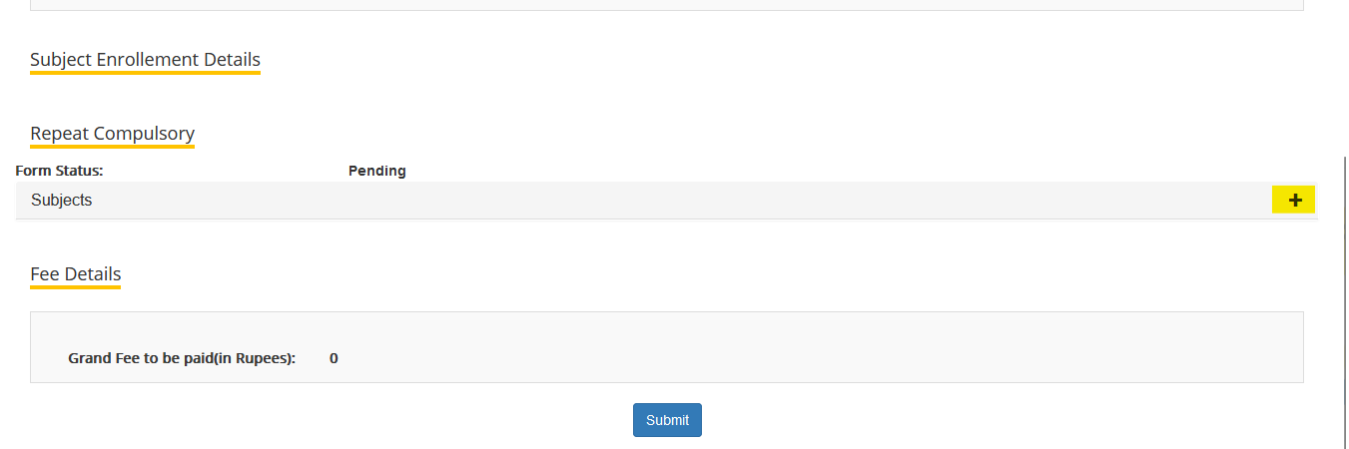

- Semester name will be visible to select the subject
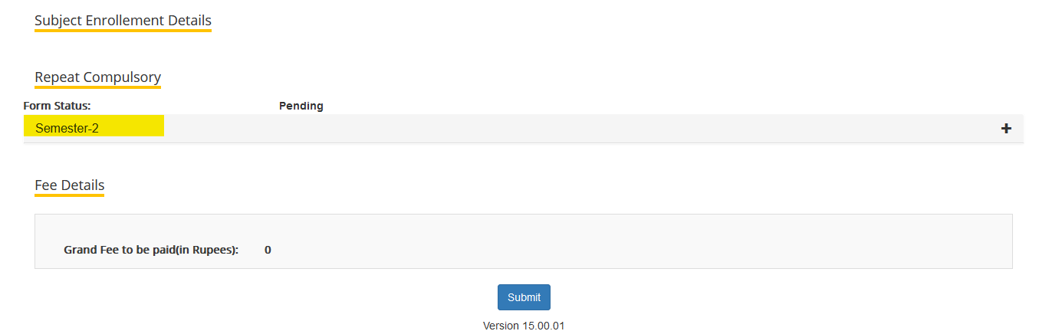

- On clicking the + icon to select the subject

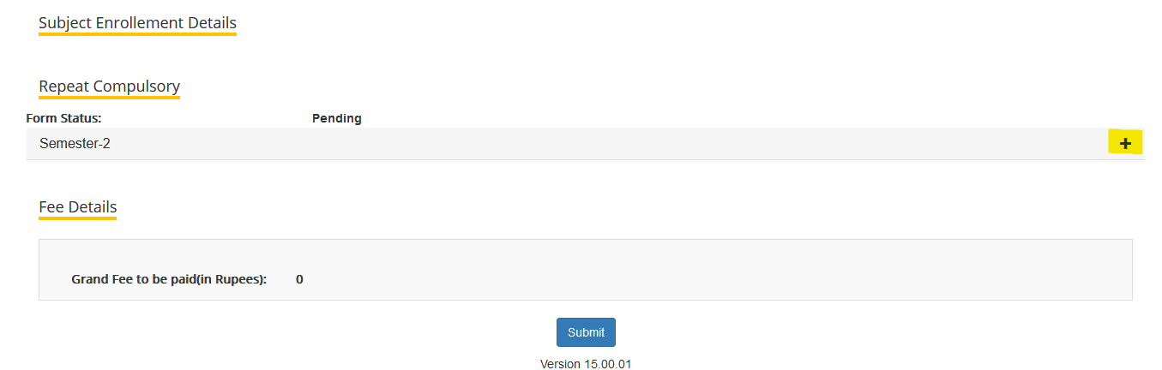
- Select the repeat subject
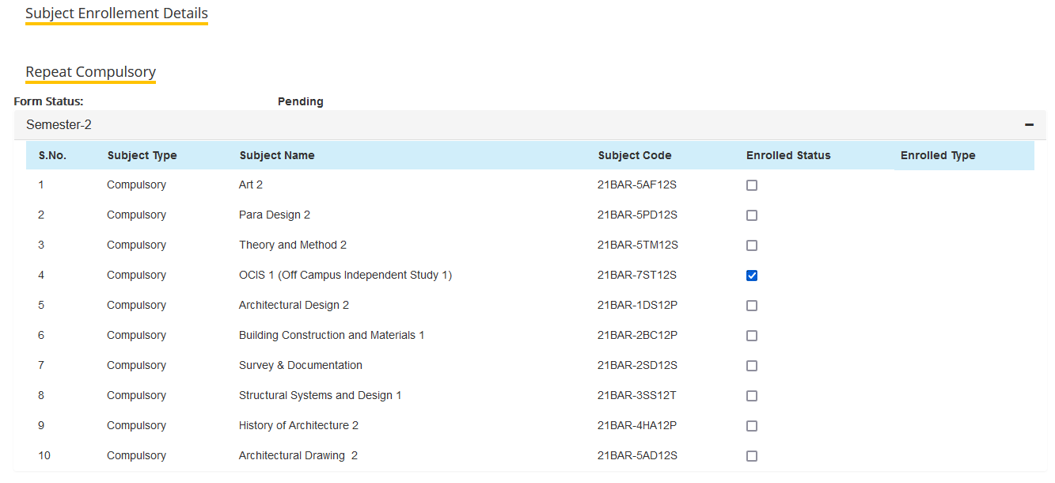

- Verify the fee details click on submit button.
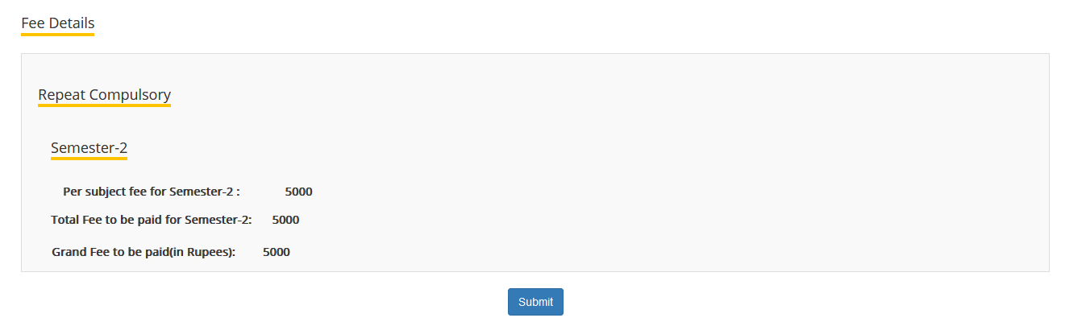

- Click "Proceed".
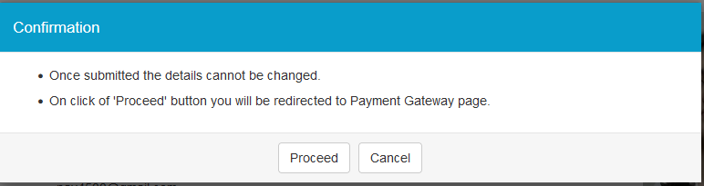
- Click “Pay Now” 