Step 1) Candidate Should Login through his/her Ion Credentials
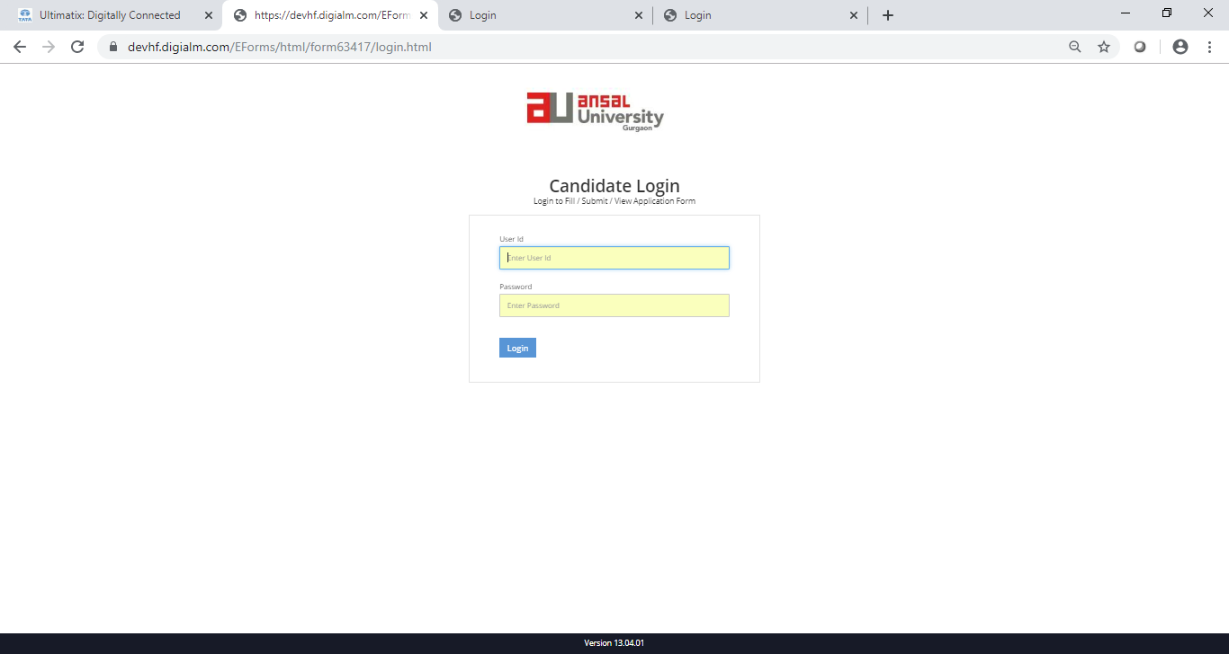

Step 2: Click on Exam Enrollment , it will redirect to you Student Detail Page

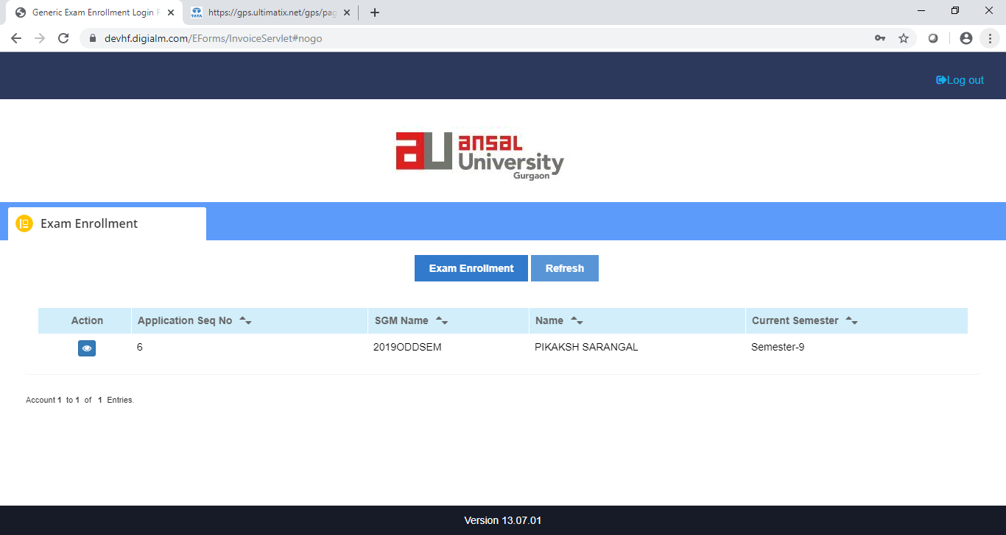
Step 3: Scroll down on page detail

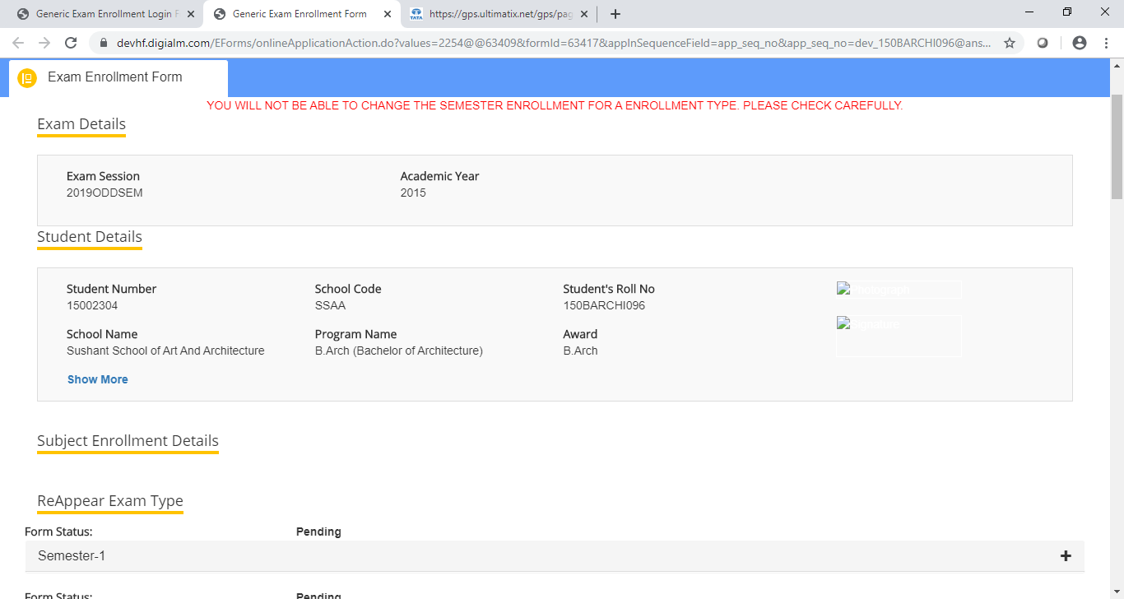

Step 4 : On Student Page detail , scroll down select the subject, student want to reappear in previous odd semesters(Reappear /Debarred/ Improvement) . Below Categories are for B. Arch and M.Arch
- Reappear
- Improvement
- Debarred

For other awards reappear and Improvement is applicable

- Subject and Semester selected in particular Exam Type cannot be changed further
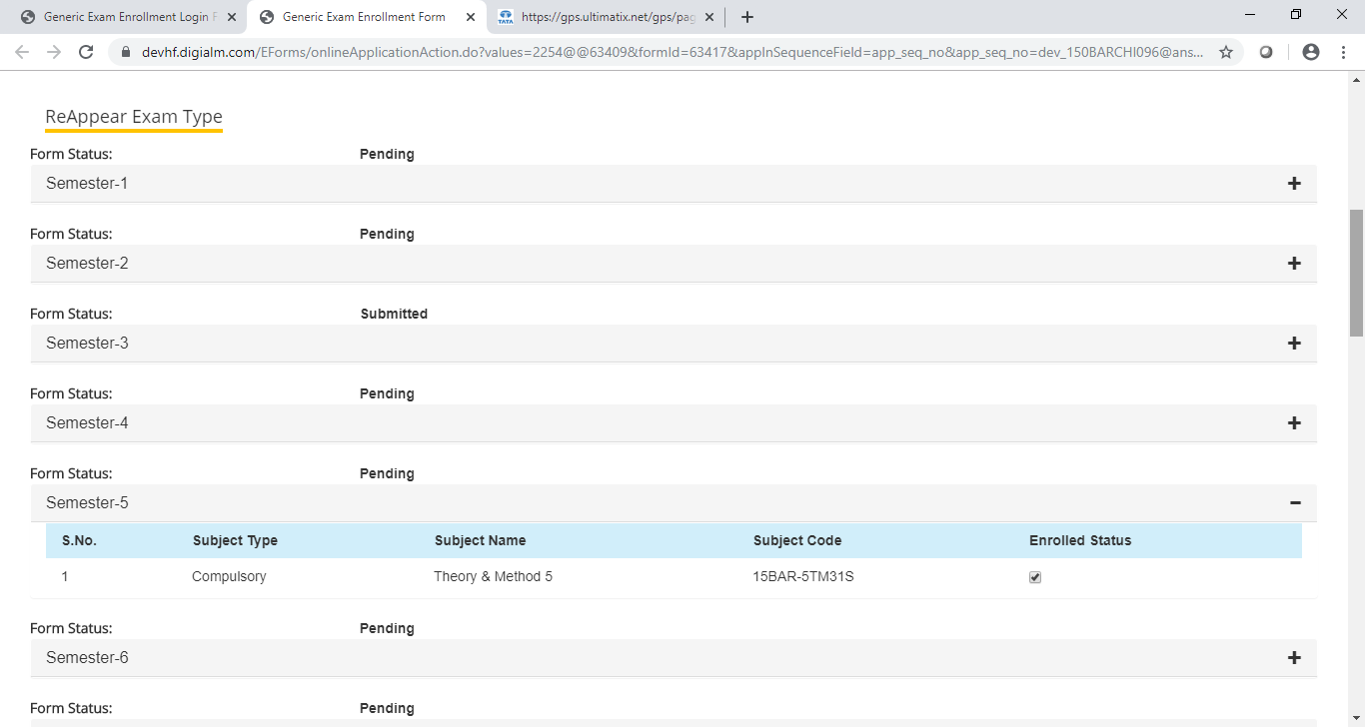
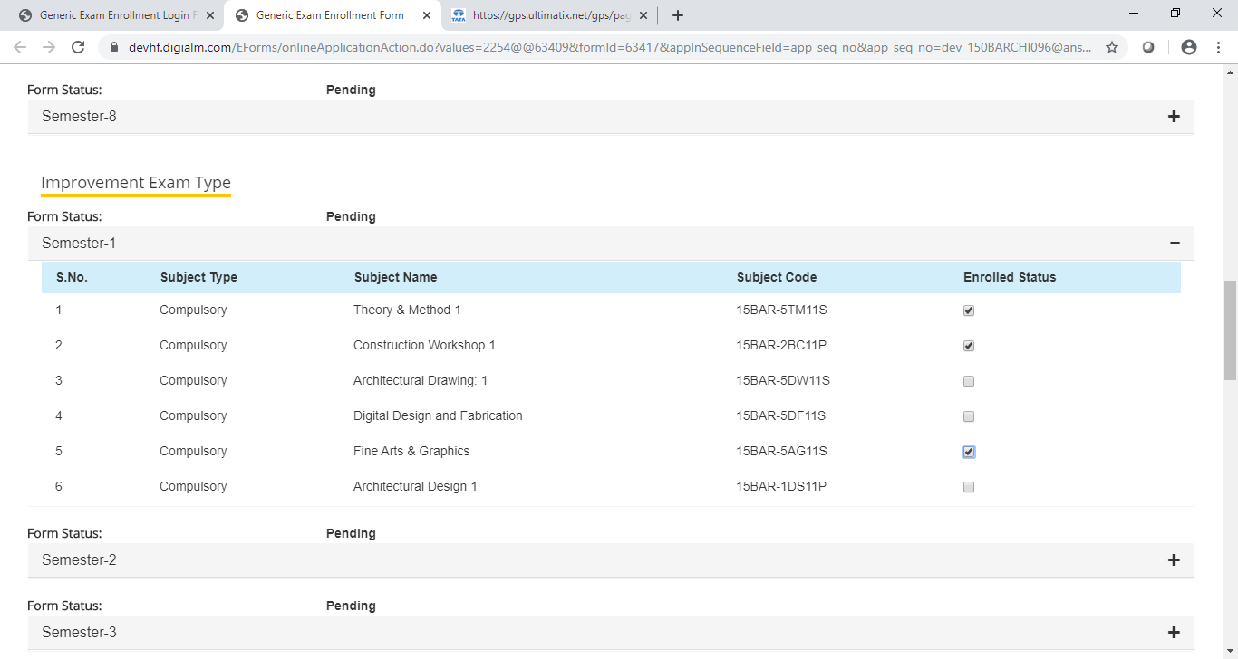

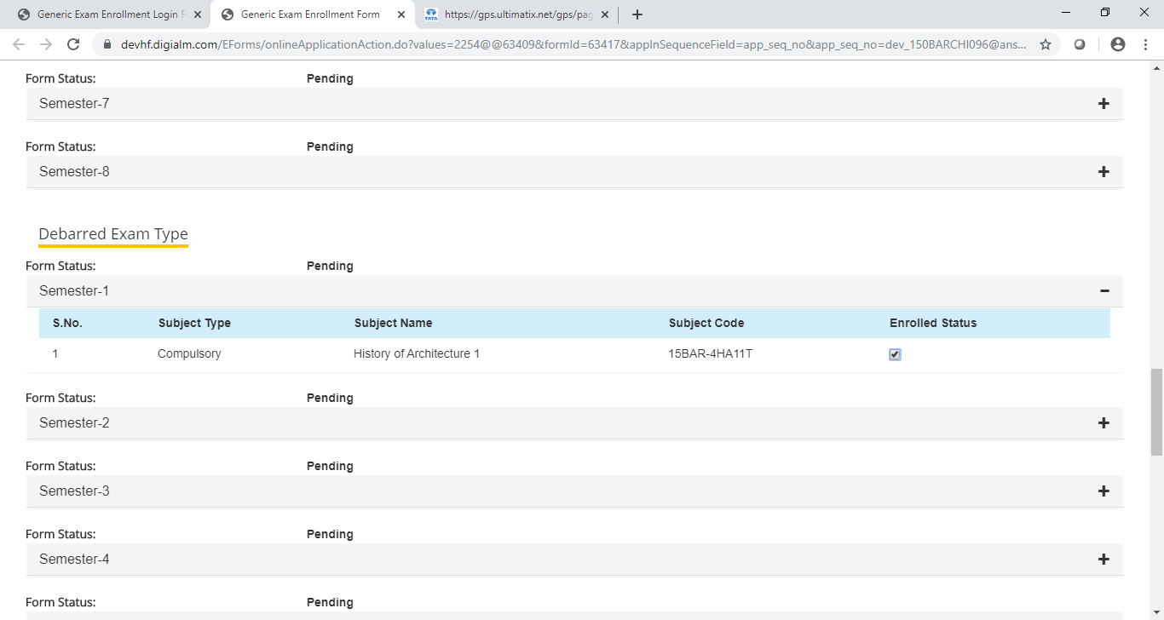
Step 5 : Check the Fees and Submit it will redirect you to Pay u Page
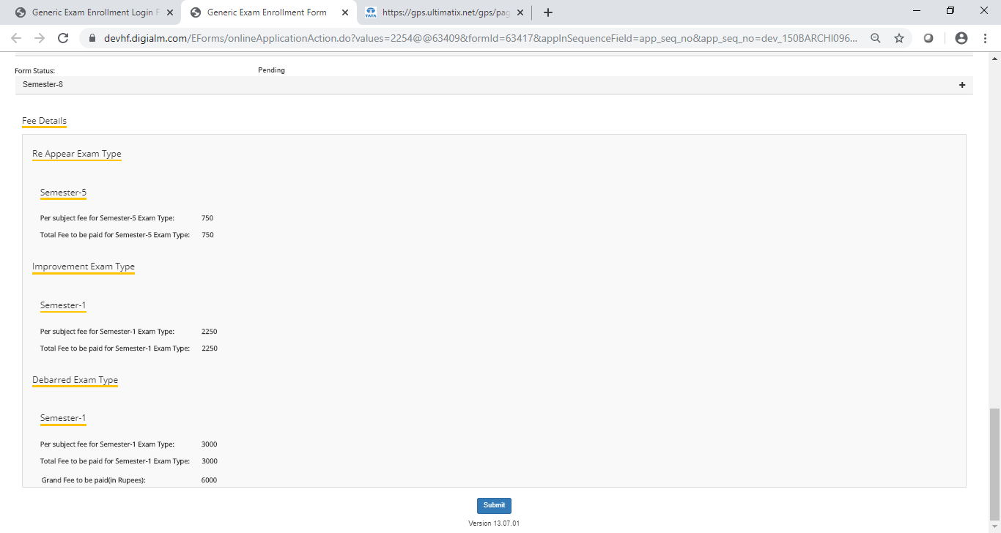

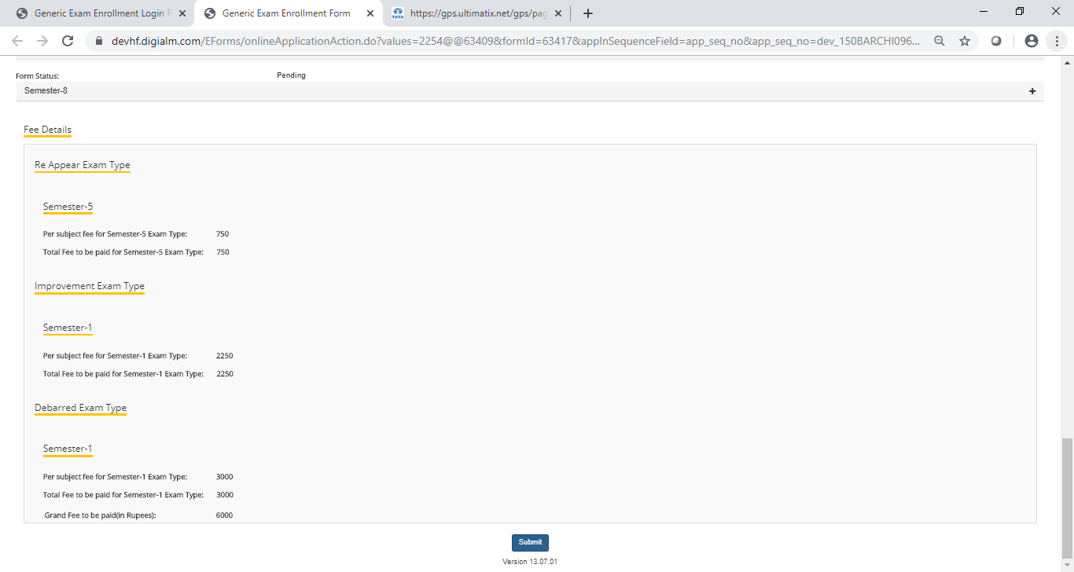

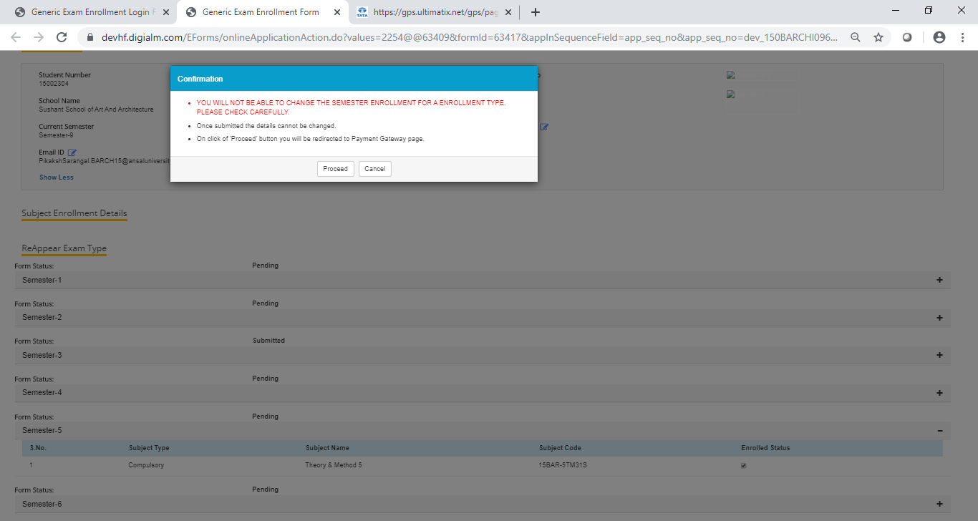

Step 6 : Submit your Fees and Hall Ticket will be generated instantly
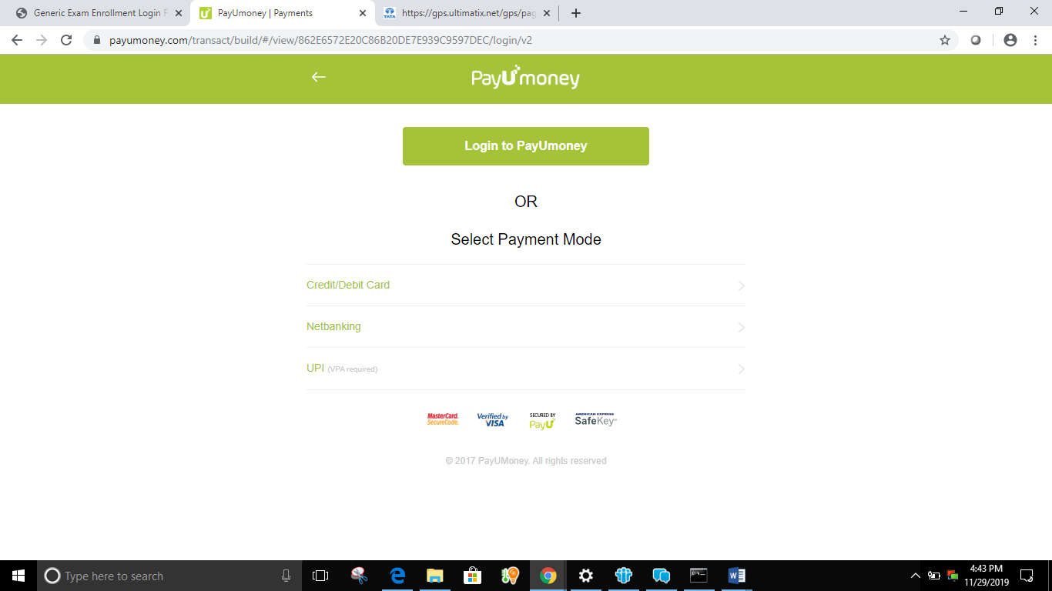

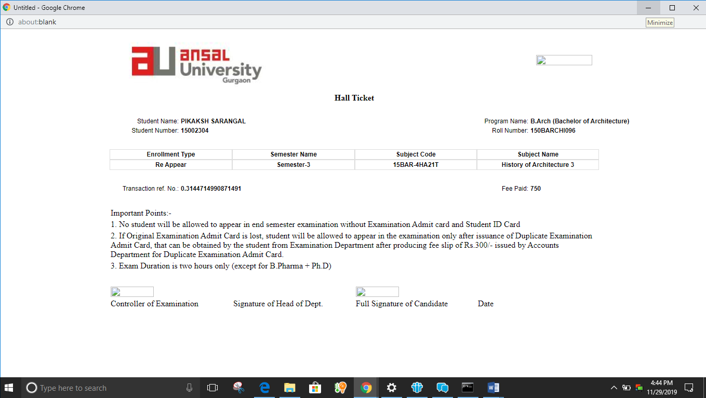

To View Hall Ticket , click on Action on left

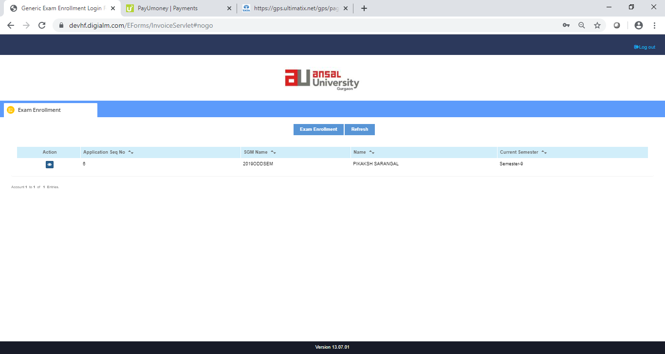

Student can directly view the Headcount
