**Dec 2024 Odd Regular Form Help File**

**Note:**

* **Forget Password concern follow the steps mentioned in password reset help file.**
* **Please do not submit the form if the subject is incorrect, as we are not able to make any changes after submission. Please contact the relevant department to update the subject.**

1. Open the website **TCSion Self Service** on google chrome normal browser of Desktop/Laptop, below is the URL for the same.

<https://www.tcsion.com/SelfServices/>

1. Insert your login credentials then Click "Login"

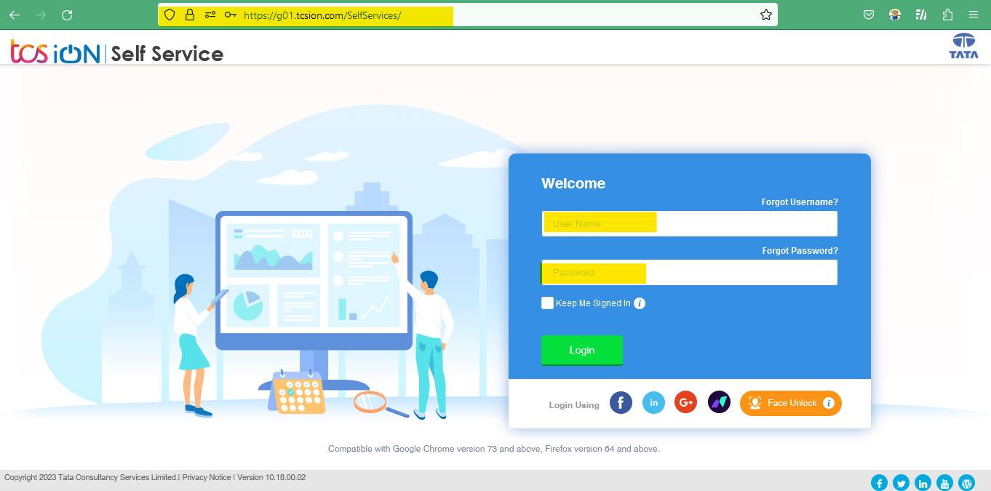

1. Click "Exam & Grading icon then click Exam Enrollment A screenshot of a computer

   Description automatically generated
2. Click "Exam Enrollment"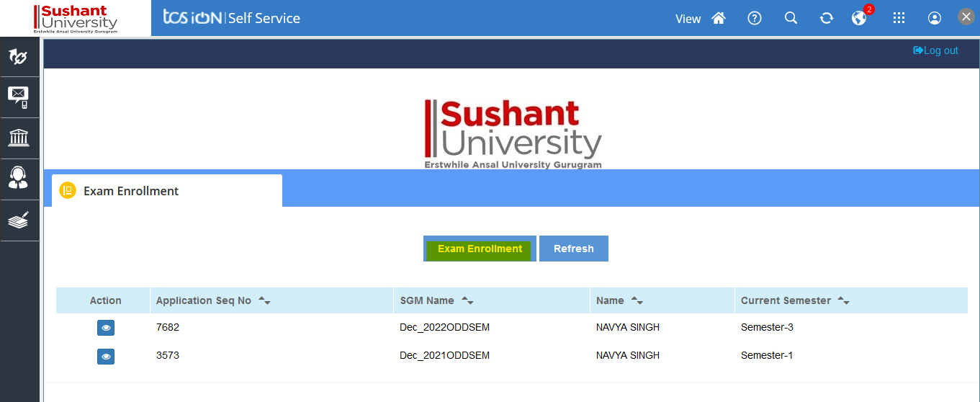
3. To view the subject enrollment details, go to the Regular Enrollment section and click the plus icon.

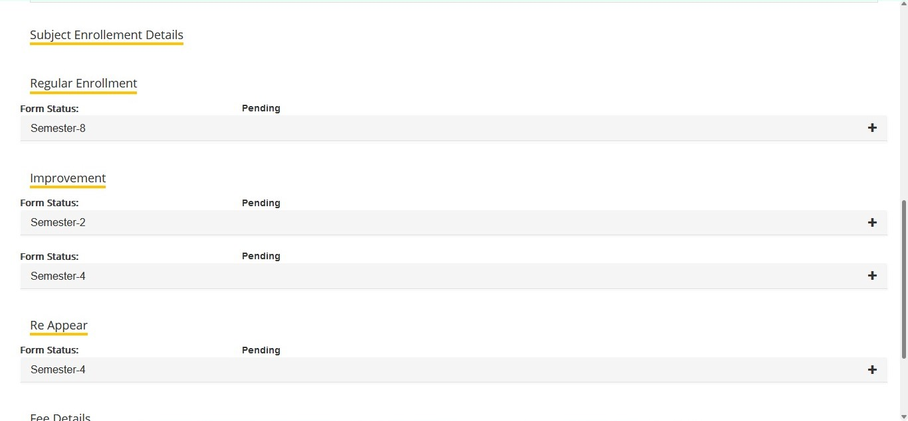

1. If the fee has not been cleared, the fee due error will appear, and you will be able to apply once the fee has been cleared. 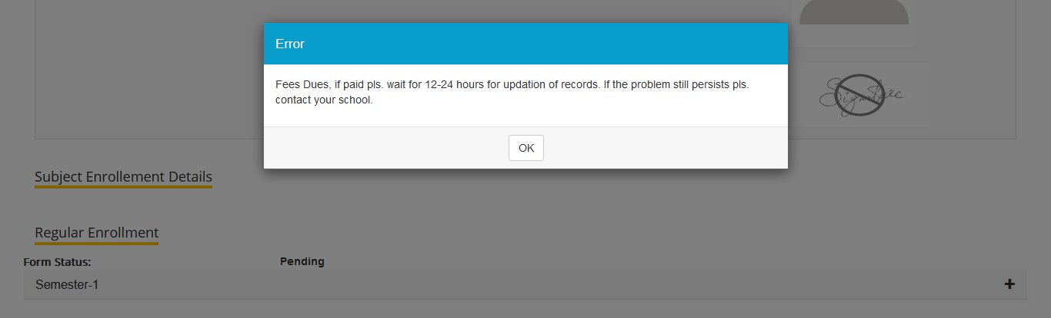
2. On clicking the + icon to verify the subject

1. Verify the fee details and click the submit button. In the case of late applications, the due amount will be shown. A screenshot of a computer

   Description automatically generated
2. Read the information then on Click "Proceed".

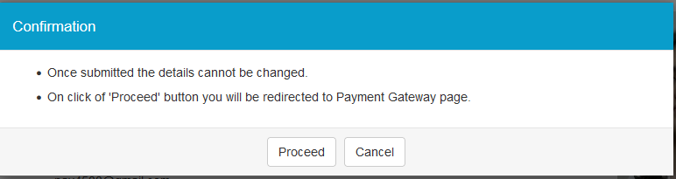

1. select the payment options and pay the amount.

1. After the exam department approves the regular form, the Admit Card will be available for download and printing.

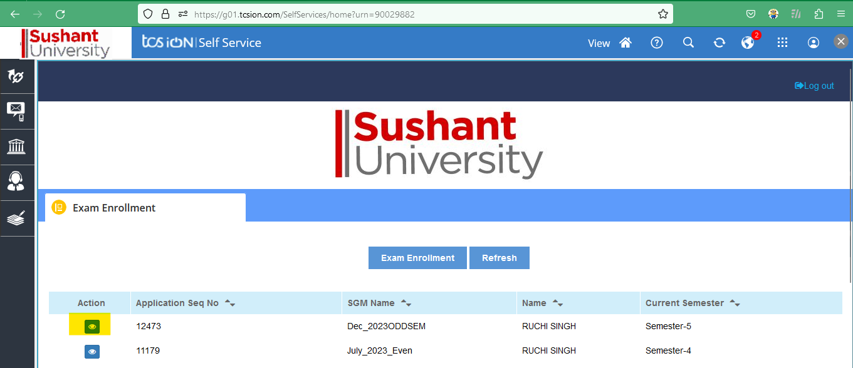

Note: For any technical issue contact at "erpsupport@sushantuniversity.edu.in"